**ABOUT PROJECT**

The project Tours and Travels has been developed to help and facilitate users to arrive at the best travel package. The program has been developed and coded in python language and all related information about the various available packages with different service providers will be emailed on their registered mail account. The program provides user the option to get desired details based on their choice of location, budget and duration.

The program has been developed on Python 3.6.7 and databased used is MySql Server 5.1.

SOFTWARE AND HARDWARE

SOFTWARE:

* Python 3.6.7
* MySql Server 5.1
* Windows 10, 64 Bit Operating System

HARDWARE:

* HP Laptop Intel® Core™ i3-7020U [CPU@2.30GHZ](mailto:CPU@2.30GHZ) x-64 based processor

MODULES

* mysql.connector
* datetime

Functions

Functions defined in this project are as follows:

* userdataA_()
* UpdateUData_()
* UDataDel_()
* SignupA_()
* admin_login()
* admin_DATA_()
* Signup_()
* Udata_()
* calendar_()
* user_()
* login_()
* admin1_()
* main()

**SOURCE CODE**

***#CONNECTION***

import mysql.connector

mydb=mysql.connector.connect(host="localhost",user="root",passwd="Ansh130204",database="Travels")

import datetime

***#CONNECTION SUCCESS***

if mydb.is_connected():

print("Succesfull Connection")

***#CURSOR***

cursor=mydb.cursor()

cursor.execute("CREATE DATABASE IF NOT EXISTS Travels")

***#USER TABLE***

cursor. execute("CREATE TABLE IF NOT EXISTS Customers(Name VARCHAR(12) NOT NULL , Age INT(3) , EMAIL_ID VARCHAR(13) , Address VARCHAR(12) , ID int(12), Passwd INT(12),PRIMARY KEY(ID,Passwd))")

p1="INSERT INTO Customers(Name,Age,EMAIL_ID,Address,ID,Passwd) VALUES(%s,%s,%s,%s,%s,%s)"

s1=("Aditya","18","aditya22","Delhi-92","1005","1009")

cursor.execute(p1,s1)

mydb.commit()

***#TRIPS Table***

cursor.execute("CREATE TABLE IF NOT EXISTS Trips(C_ID INT(12) NOT NULL,PastLoc VARCHAR(12)NULL ,Date DATE NULL,UpcomTrips VARCHAR(12) NULL,Date_1 DATE NULL)" )

g1="INSERT INTO Trips(C_ID,PastLoc,Date,UpcomTrips,Date_1) VALUES(%s,%s,%s,%s,%s)"

T1=("1005","NYC",datetime.datetime(2002,12,31),"PARIS",datetime.datetime(2003,3,20))

cursor.execute(g1,T1)

mydb.commit()

***#ADMIN TABLE***

cursor. execute("CREATE TABLE IF NOT EXISTS Admin(Name VARCHAR(12) NOT NULL , Age INT(3) , EMAIL_ID VARCHAR(21) , Address VARCHAR(21) , ID int(12), Passwd INT(12),PRIMARY KEY(ID,Passwd))")

t2="INSERT INTO Admin(Name,Age,EMAIL_ID,Address,ID,Passwd) VALUES(%s,%s,%s,%s,%s,%s)"

sql9=("Lucky","23","lucky22","Delhi-92","1009","1005")

cursor.execute(t2,sql9)

mydb.commit()

***#USER DATA BY ADMIN***

def userdataA_():

x=int(input("Enter UserId Of The User"))

cursor.execute("SELECT * FROM Customers")

record=cursor.fetchall()

for i in record:

if(i[4]==x):

print("*********************")

print("The Details Of The User Is As Follows","\n","Name :",i[0],"\n","AGE",i[1],"\n","EMAIL ID:",i[2],"\n","ADDRESS:",i[3],"\n","USER ID",i[4],"PASSWORD",i[5])

print("**********************")

else:

print("TRY AGAIN PLEASE")

userdataA_()

print("\n")

print("**************************************")

print("PRESS 1 TO CONTNUE")

print("PRESS 2 TO GO BACK TO ADMIN LOGIN")

print("PRESS ANY KEY TO GO BACK TO MAIN MENU")

print("**************************************")

r=int(input("ENTER YOUR CHOICE"))

print("\n")

if r==1:

print("\n")

userdataA_()

if r==2:

print("\n")

admin_login()

else:

print("\n")

main()

print("\n")

***#UPGRADATION OF USER DATA BY ADMIN***

def UpdateUData_():

print("**************************")

print("PRESS 1 TO CHANGE NAME")

print("PRESS 2 TO CHANGE AGE")

print("PRESS 3 TO CHANGE EMAIL ID")

print("PRESS 4 TO CHANGE ADDRESS")

print("**************************")

print("\n")

r=int(input("enter your choice: "))

n=int(input("ENTER THE ID OF THE CUSTOMER TO BE CHANGED"))

cursor.execute("SELECT * FROM CUSTOMERS")

res=cursor.fetchall()

for i in res:

if(i[4]==n):

***#update name***

if(r==1):

print("\n")

z=input("ENTER NEW NAME: ")

t4="UPDATE Customers set Name= %s WHERE ID=%s "

input1=(z,n)

cursor.execute(t4,input1)

mydb.commit()

print("THE NAME OF USER HAS BEEN CHANGED TO",n)

***#update age***

elif(r==2):

print("\n")

z1=int(input("ENTER NEW AGE: "))

t4="UPDATE Customers set Age=%s WHERE ID=%s "

input1=(z1,n)

cursor.execute(t4,input1)

mydb.commit()

print("THE AGE OF USER HAS BEEN CHANGED TO",z1)

***#update email id***

elif(r==3):

print("\n")

z2=input("ENTER NEW EMAIL ID: ")

t4="UPDATE Customers set Email_ID=%s WHERE ID=%s "

input1=(z2,n)

cursor.execute(t4,input1)

mydb.commit()

print("THE EMAIL ID OF USER HAS BEEN CHANGED TO",z2)

***#update address***

elif(r==4):

print("\n")

z3=input("ENTER NEW ADDRESS: ")

t4="UPDATE Customers set Address=%s WHERE ID=%s "

input1=(z3,n)

cursor.execute(t4,input1)

mydb.commit()

print("THE ADDRESS OF USER HAS BEEN CHANGED TO",z3)

print("\n")

print("*********************************")

print("PRESS 1 TO CONTNUE")

print("PRESS 2 TO GO BACK TO ADMIN LOGIN")

print("***********************************")

print("\n")

r=int(input("ENTER YOUR CHOICE"))

if r==1:

print("\n")

UpdateUData_()

if r==2:

print("\n")

admin_login()

else:

print("\n")

main()

print("\n")

***#DELETION OF USER DATA BY ADMIN***

def UDataDel_():

print("\n")

x=int(input("Enter The UserID Of User "))

sql3="DELETE FROM Customers WHERE ID='x' "

cursor.execute(sql3)

print("DATA OF USER DELETED")

mydb.commit()

print("\n")

print("**********************************")

print("PRESS 1 TO CONTNUE")

print("PRESS 2 TO GO BACK TO ADMIN LOGIN")

print("***********************************")

r=int(input("ENTER YOUR CHOICE"))

print("\n")

if r==1:

print("\n")

UDataDel_()

if r==2:

print("\n")

admin_login()

else:

print("\n")

main()

print("\n")

***#ADMIN SIGNUP***

def SignupA_():

print("******************************************************")

a=input("ENTER YOUR NAME")

o=int(input("ENTER YOUR AGE"))

b=input("ENTER YOUR EMAIL")

c=input("ENTER YOUR ADDRESS")

d=int(input("ENTER THE ID GIVEN TO YOU VIA ADMINISTRATION"))

e=int(input("ENTER THE PASSWD GIVEN TO YOU VIA ADMINISTRATION"))

print("******************************************************")

t1="INSERT INTO Admin(Name,Age,EMAIL_ID,Address,ID,Passwd) VALUES(%s,%s,%s,%s,%s,%s)"

s=(a,o,b,c,d,e)

cursor.execute(t1,s)

mydb.commit()

print("YOU ARE SUCCESSFULLY REGISTERED TO OUR AGENCY")

print("\n")

print("**********************************")

print("PRESS 1 TO GO TO ADMIN LOGIN")

print("PRESS ANY KEY TO GO BACK TO MAIN MENU")

print("**********************************")

r=int(input("ENTER YOUR CHOICE"))

print("\n")

if r==1:

print("\n")

admin_login()

else:

print("\n")

main()

print("\n")

***#ADMIN LOGIN***

def admin_login():

global w

global w1

print("*****************************")

w=int(input("ENTER ADMIN ID: "))

w1=int(input("ENTER ADMIN PASSWORD: "))

print("******************************")

cursor.execute("SELECT * FROM Admin")

res=cursor.fetchall()

op=1

for i in res:

if(i[4]==w and i[5]==w1):

op=0

break

else:

op=1

if op==0:

print("\n")

print("WELCOME ADMIN:",i[0])

print("***************************")

print("PRESS 1 TO SEE USER DATA")

print("PRESS 2 TO UPDATE USER DATA")

print("PRESS 3 TO DELETE USER DATA")

print("PRESS 4 TO SEE YOUR DATA")

print("PRESS 5 TO MAIN MENU")

print("****************************")

c=int(input("Enter Your Choice"))

print("\n")

if c==1:

print("\n")

userdataA_()

if c==2:

print("\n")

UpdateUData_()

if c==3:

print("\n")

UDataDel_()

if c==4:

print("\n")

admin_DATA_()

if c==5:

print("\n")

main()

else:

print("\n")

print("**************************************")

print("TO TRY AGAIN PRESS 1")

print("TO GO BACK TO HOME PAGE PRESS ANY KEY")

print("**************************************")

n=int(input("ENTER YOUR CHOICE PLEASE"))

if n==1:

print("\n")

admin_login()

else:

print("\n")

main()

print("\n")

***#ADMIN DATA***

def admin_DATA_():

cursor.execute("SELECT * FROM Admin")

record=cursor.fetchall()

for i in record:

if(i[4]==w):

print("*********************")

print("The Details OfF YOU Is As Follows","\n","Name :",i[0],"\n","AGE",i[1],"\n","EMAIL ID:",i[2],"\n","ADDRESS:",i[3],"\n","USER ID",i[4],"PASSWORD",i[5])

print("**********************")

else:

print("\n")

print("************************************************")

print("SORRY;;;WRONG PASSWORD")

print(" TO TRY AGAIN PRESS 1")

print("PRESS ANY OTHER KEY TO GO BACK TO ADMIN PORTAL")

print("************************************************")

e=int(input("ENTER YOUR OPTIONS"))

if y==1:

print("\n")

userdataA_()

else:

print("\n")

admin_login()

print("\n")

print("************************************************")

print("PRESS 1 TO CONTNUE")

print("PRESS 2 TO GO BACK TO ADMIN LOGIN")

print("PRESS ANY KEY TO GO BACK TO MAIN MENU")

print("************************************************")

r=int(input("ENTER YOUR CHOICE"))

print("\n")

if r==1:

admin_DATA_()

if r==2:

admin_login()

else:

main()

print("\n")

***#SIGNUP BY USER***

def Signup_():

print(" WELCOME;;; REGISTER YOURSELF QUICKLY AND LEAVE YOUR HOLIDAYS TO US")

print("**********************************************")

a=input("ENTER YOUR NAME")

o=int(input("ENTER YOUR AGE"))

b=input("ENTER YOUR EMAIL")

c=input("ENTER YOUR ADDRESS")

d=int(input("ENTER THE ID GIVE TO YOU BY THE ADMINISTRATION"))

e=int(input("ENTER THE PASSWD GIVEN TO YOU BY THE ADMINISTRATION"))

print("**********************************************")

t1="INSERT INTO Customers(Name,Age,EMAIL_ID,Address,ID,Passwd) VALUES(%s,%s,%s,%s,%s,%s)"

s=(a,o,b,c,d,e)

cursor.execute(t1,s)

mydb.commit()

print("YOU ARE SUCCESSFULLY REGISTERED TO OUR AGENCY")

print("*******************************************")

print("Do U WISH TO GO TO LOGIN PORTAL:IF YES PRESS 1","\n","TO GO TO HOME PAGEPRESS 2","\n")

print("*******************************************")

x=int(input("Enter Your Choice"))

if x==1:

print("\n")

user_()

if x==2:

print("\n")

main()

else:

print("\n")

print("********************************")

print("SORRY WRONG OPTION")

print("YOU ARE REDIRECTED TO HOME PAGE")

print("********************************")

print("\n")

main()

print("\n")

***#USER DATA SEEN BY USER***

def Udata_():

cursor.execute("SELECT * FROM CUSTOMERS")

res=cursor.fetchall()

for i in res:

if(i[4]==l and i[5]==p):

print("WELCOME :")

print("*****************************")

print("YOUR DETAILS ARE AS FOLLOWS","\n","Name :",i[0],"\n","AGE",i[1],"\n","EMAIL_ID:",i[2],"\n","ADDRESS:",i[3],"\n")

print("*****************************")

print("********************************")

print("PRESS 1 TO BACK TO HOME PAGE","\n","PRESS 2 TO GO BACK TO YOUR USER PORTAL","\n","PRESS 3 TO LEAVE SITE")

print("********************************")

K=int(input("PLEASE ENTER YOUR OPTIONS"))

if(K==1):

print("\n")

main()

if(K==2):

print("\n")

user_()

if(K==3):

print("\n")

print("\n")

if(K==1):

main()

if(K==2):

user_()

if(K==3):

print("\n")

***#CALENDAR/PLACES WHERE CUSTOMER HAS GONE AND WANTS TO GO***

def calendar_():

print("******************************************")

print("PRESS 1 TO CHECK YOUR UPCOMING/PAST TRIPS")

print("PRESS 2 TO PLAN A TOUR")

print("******************************************")

q=int(input("PLEASE ENTER YOUR OPTION"))

#NEW LINE CHARACTER

print("\n")

#DETAILS OF THE TRIP

if(q==1):

cursor.execute("SELECT * FROM Trips" )

leg=0

ref=cursor.fetchall()

**#WAY TO FIND THE SPECIFIC PERSON IN THE LIST OF CUSTOMERS**

for key in ref:

if(key[0]==l):

leg=1

break

else:

leg=0

if(leg==1):

***#DETAILS OF THE TRIP***

print("YOUR TRIP DETAILS ARE AS FOLLOWS")

print("***************************************")

print("PAST LOCATION :",key[1],"\n","Date:",key[2])

print("FUTURE LOCATION:",key[3],"\n","DATE:",key[4])

print("***************************************")

***#PACKAGES/BOOKING OF THE TRIP***

if(q==2):

print("******************************************")

print("PLEASE SELECT YOUR BEST PACKAGES AVAILABLE")

print("PRESS 1 FOR 3 NIGHT AND 2 DAYS IN USA")

print("PRESS 2 FOR 10 DAY TRIP TO EUROPE")

print("PRESS 3 FOR 5 DAY TRIP TO CHINA")

print("PRESS 4 FOR 3 DAY TRIP TO GUJARAT")

print("PRESS 5 FOR 6 DAY TRIP TO GOA")

print("PRESS 6 FOR ANY OTHER PLACE")

print("******************************************")

d=int(input("ENTER YOUR CHOICE"))

if(d in (1,2,3,4,5)):

print("REQUESTED BROCHURE AND DETAILS ARE SEND TO YOUR REQUESTED EMAIL ID")

if(d==6):

print("***********************************")

a=input("ENTER YOUR LOCATION")

b=int(input("ENTER THE BUDGET OF YOUR TRIP"))

c=input("ENTER THE DURARTION OF YOUR TRIP")

print("***********************************")

print("ALL NECESSARY INFORMATION INCLUDING BROCHURE AND DISCOUNT BOOKLET IS SEND TO OUR REGISTERED EMAIL ID")

print("\n")

print("****************************")

print("PRESS 1 TO BACK TO HOME PAGE","\n","PRESS 2 TO GO BACK TO YOUR USER PORTAL","\n","PRESS 3 TO LEAVE SITE")

print("****************************")

K=int(input("PLEASE ENTER YOUR OPTIONS"))

if(K==1):

main()

if(K==2):

user_()

if(K==3):

print("\n")

***#USER PORTAL***

def user_():

global l

global p

l=int(input("ENTER YOUR ID PLEASE"))

p=int(input("ENTER YOUR PASSWORD"))

cursor.execute("SELECT * FROM Customers")

res=cursor.fetchall()

flag=0

for i in res:

if(i[4]==l and i[5]==p):

flag=1

break

if(flag==1):

print("\n")

print("WELCOME:",i[0])

print("******************************")

print("PRESS 1 TO VIEW DATA")

print("PRESS 2 TO CHECK YOUR CALENDAR")

print("Press 3 To Go Back To Login")

print("Press 4 To Go To Home Page")

print("******************************")

print("\n")

c=int(input("PLEASE ENTER YOUR CHOICE"))

print("\n")

if c==1:

Udata_()

if c==2:

calendar_()

if c==3:

login_()

if c==4:

main()

else:

print("SORRY NO USER;;;;PLEASE TRY AGAIN")

print("\n")

user_()

***#LOGIN PORTAL***

def login_():

print("WELCOME TO THE SIGN IN PORTAL" )

print("****************************")

print("PRESS 1 IF YOU ARE A USER")

print("PRESS 2 IF YOU ARE AN ADMIN")

print("PRESS 3 IF YOU WANT TO SIGN UP")

print("PRESS 4 IF FORGET PASSWORD")

print("*****************************")

y=int(input("PLEASE ENTER YOUR CHOICE"))

print("\n")

#OPTION SELECTION

if(y==1):

print(" WELCOME USER" )

user_()

if y==2:

admin_login()

if y==3:

print("\n")

print("****************************************")

print("PRESS 1 IF YOU WANT TO REGISTER AS AN ADMIN")

print("PRESS 2 IF YOU WANT TO REGISTER AS A USER")

print("PRESS ANY OTHER KEY TO GO BACK ")

print("****************************************")

p=int(input("ENTER YOUR OPTIONS"))

if p==1:

print("\n")

SignupA_()

if p==2:

print("\n")

Signup_()

else:

print("\n")

login_()

if y==4:

***#FORGOT PASSWORD OPTION***

global j

j=int(input("ENTER YOUR ID PLEASE "))

cursor.execute("SELECT * FROM Customers")

res=cursor.fetchall()

for i in res:

if(i[4]==j):

break

else:

print("PLEASE TRY AGAIN")

print("\n")

login_()

print("THE PASSWORD CHANGE LINK IS SEND TO YOUR REGISTERED EMAIL-ID:")

a=int(input("ENTER THE NEW PASSWORD YOU CHANGED"))

t1="UPDATE Customers set Passwd=%s WHERE ID=%s "

input3=(a,j)

cursor.execute(t1,input3)

mydb.commit()

print("\n")

print("TRY NOW ")

login_()

print("\n")

***#COMPLAINT REGISTRATION***

def admin1_():

print("PLEASE WRITE DOWN COMPLAINT")

a=input( "")

print("YOUR COMPLAINT HAS BEEN RECORDED AND SENT TO THE ADMINISTRATION","\n"

"SORRY FOR THE INCONVIENCE YOU WILL INFORMED WITHIN 2 HOURS")

***#HOME PAGE***

def main():

print("***************** WELCOME TO TRAVELETO:YOUR PERFECT TRAVEL PARTNER**************** ")

print("\n")

print("*****************************************")

print("PRESS 1 FOR LOGIN")

print("PRESS 2 TO VIEW OUR BEST PACKAGES")

print("PRESS 3 TO CONTACT TO OUR ADMINISTRATION ")

print("PRESS ANY OTHE KEY TO LEAVE SITE")

print("*****************************************")

print("\n")

x=int(input("ENTER YOUR OPTIONS"))

print("\n")

if(x==1):

login_()

if x==2:

print("******************************************")

print("YOUR BEST PACKAGES AVAILABLE")

print(" 3 NIGHT AND 2 DAYS IN USA")

print(" 10 DAY TRIP TO EUROPE")

print(" 5 DAY TRIP TO CHINA")

print(" 3 DAY TRIP TO GUJARAT")

print(" 6 DAY TRIP TO GOA")

print("******************************************")

print("\n")

print("LOGIN TO VIEW ARE BEST DEALS")

print("PRESS 'Y' TO CONTINUE","\n","PRESS 'NO' TO GO BACK TO HOME PAGE")

y=input("ENTER YOUR OPTION")

if y=='Y':

print("\n")

login_()

print("\n")

else:

print("\n")

main()

print("\n")

if x==3:

admin1_()

else:

print("*************THANK YOU************** ")

main()

**OUTPUTS SCREENSHOTS**

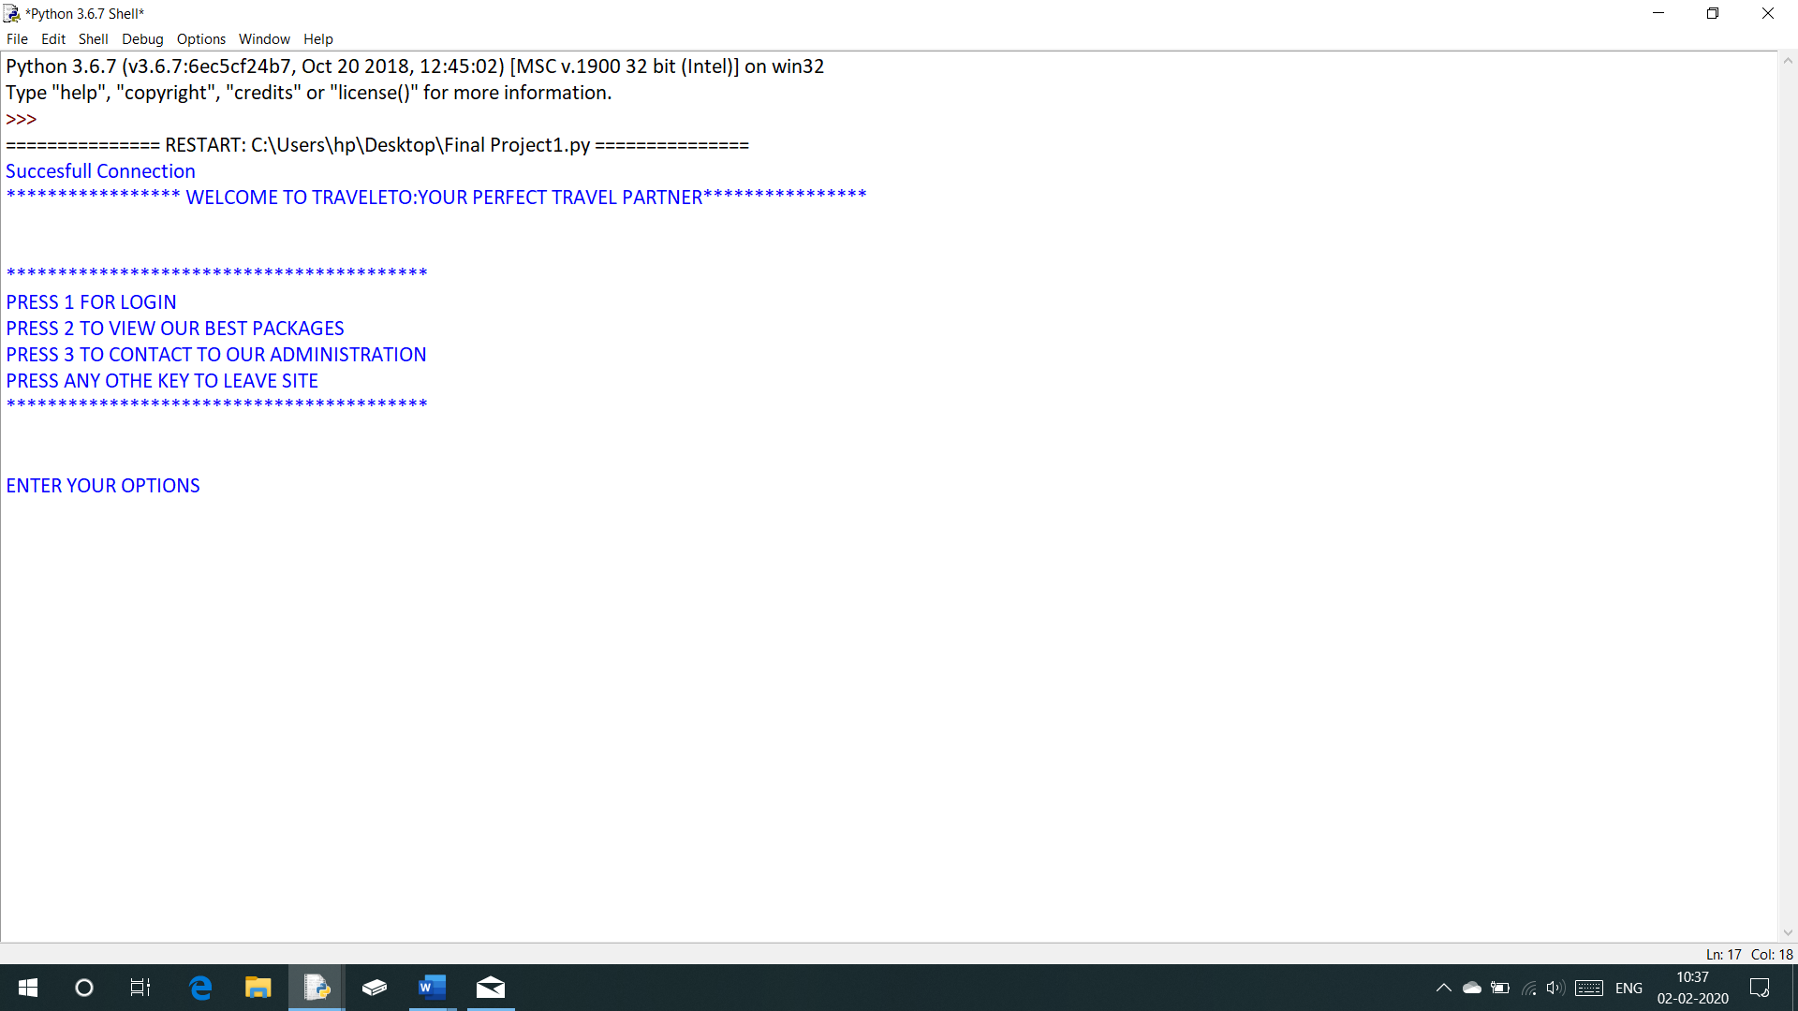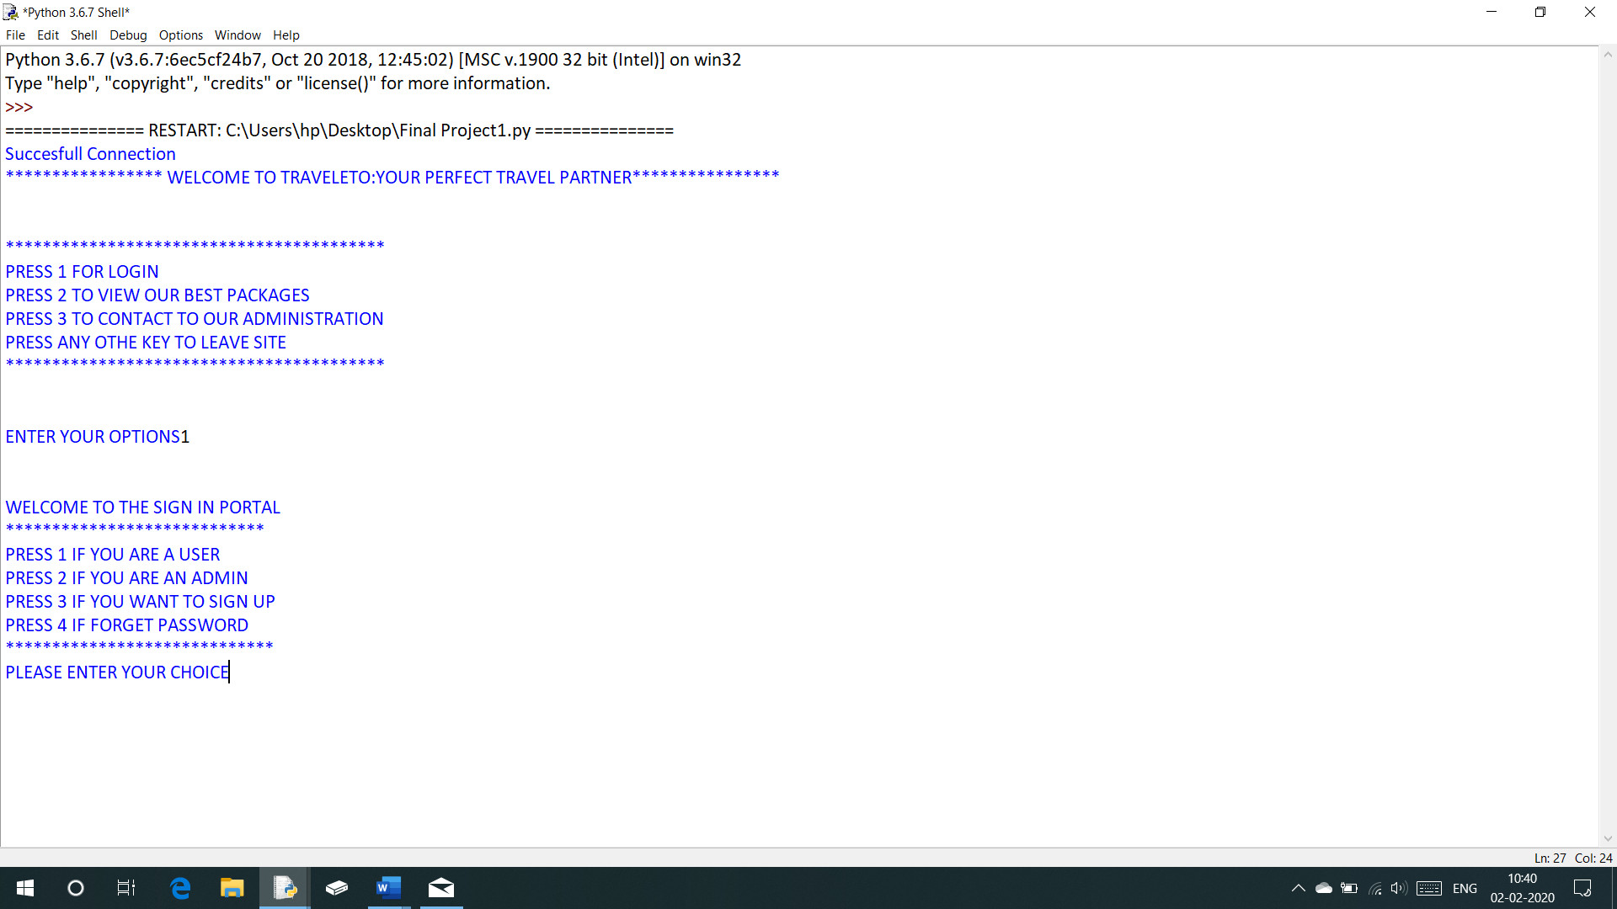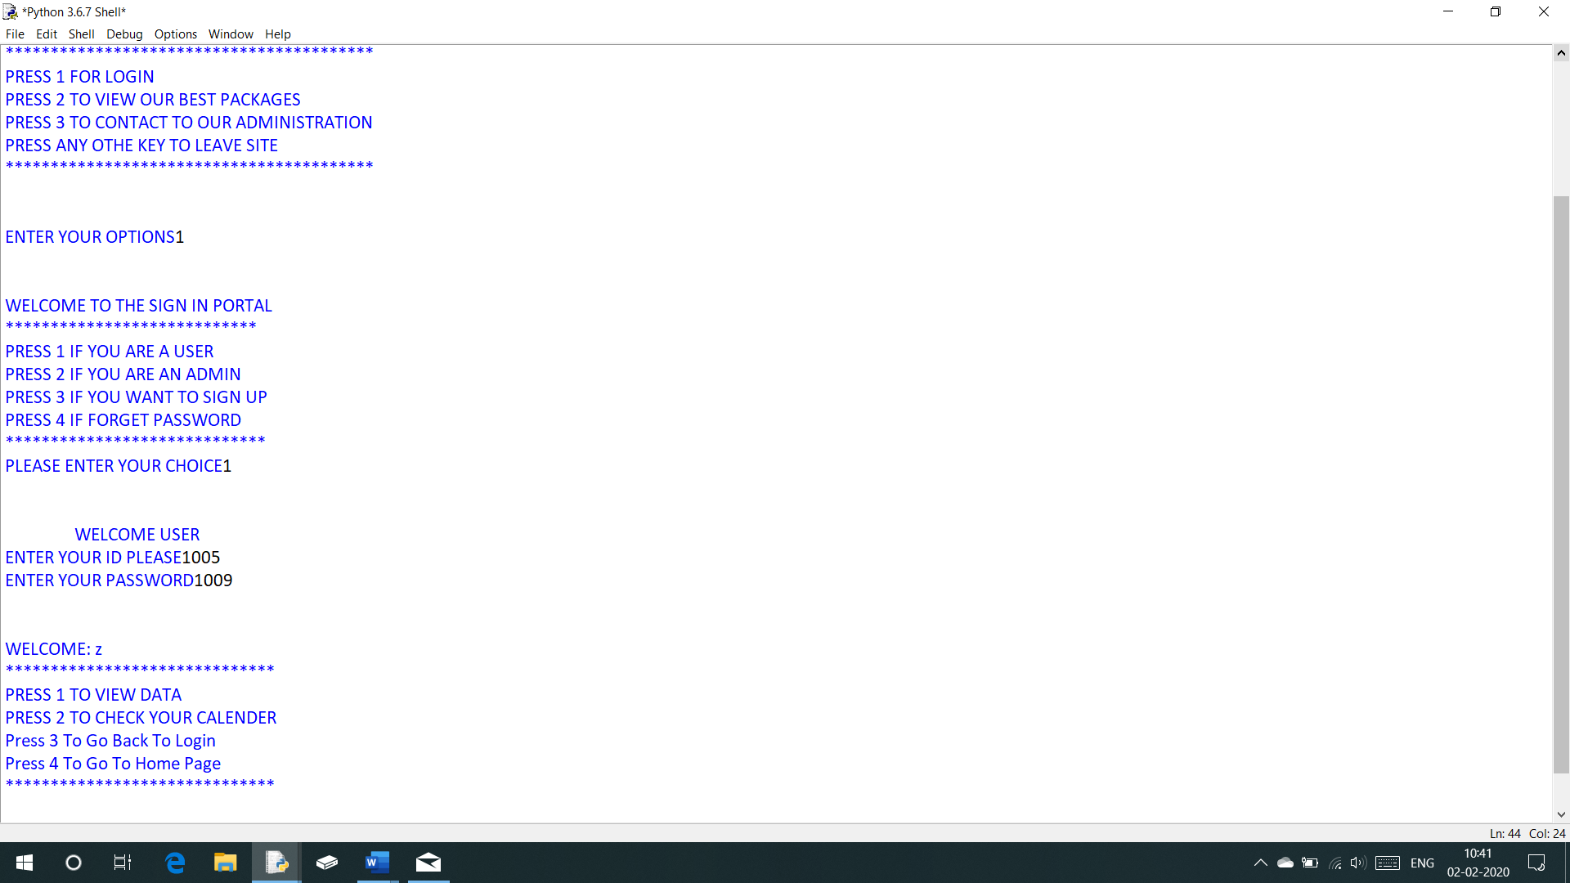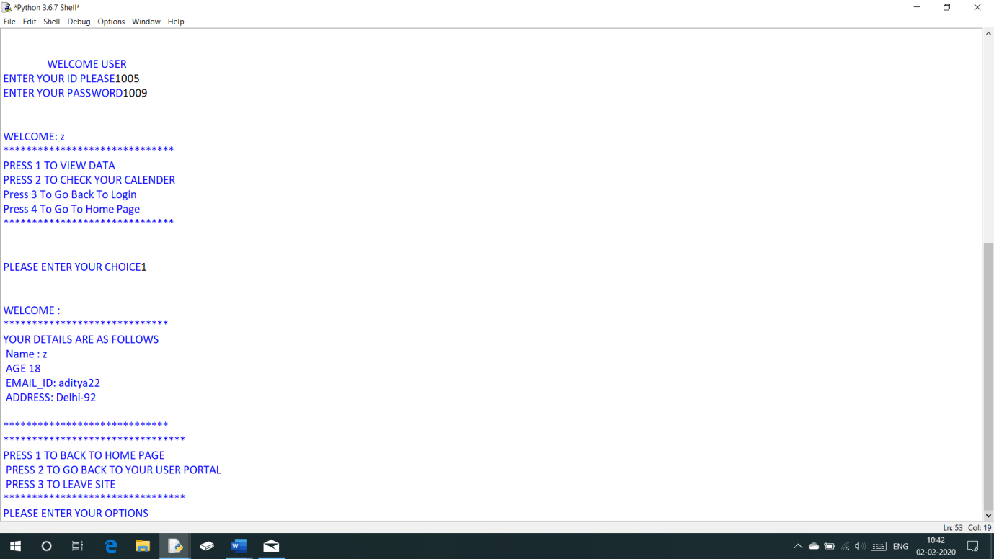

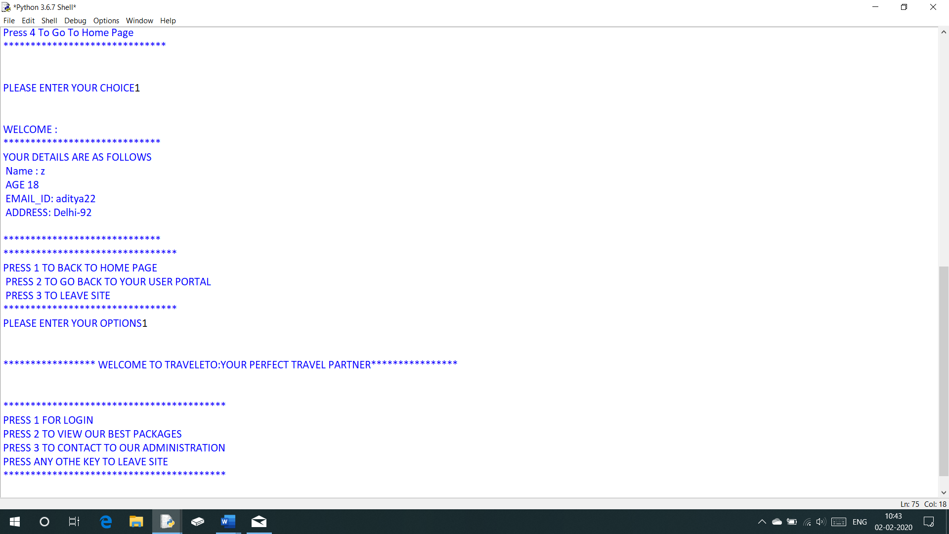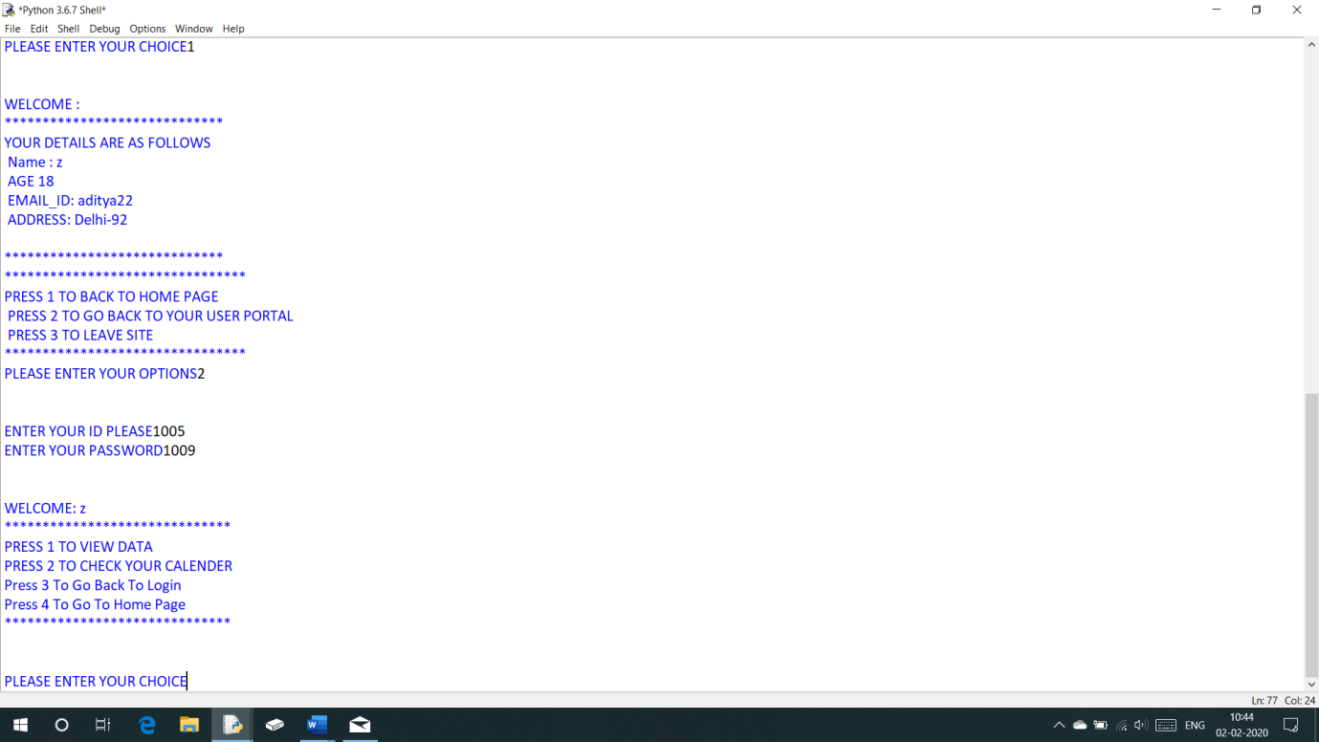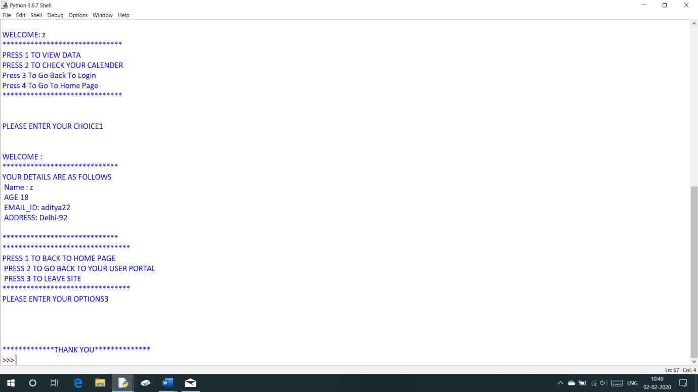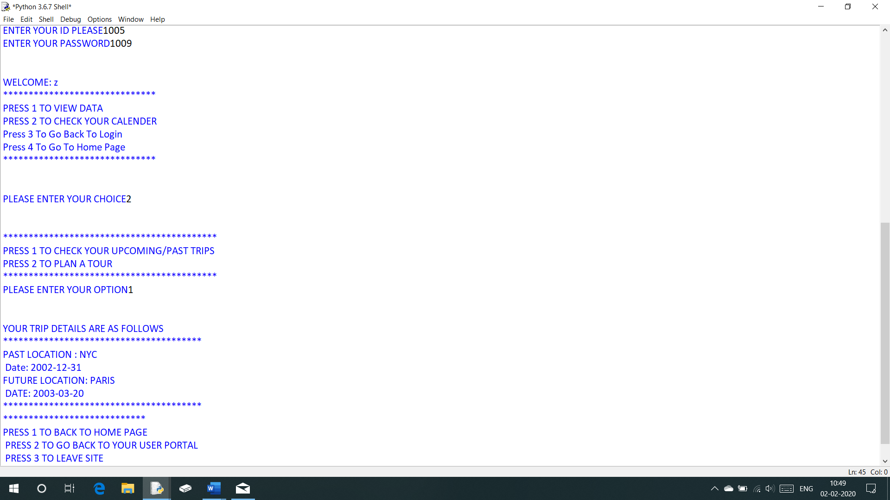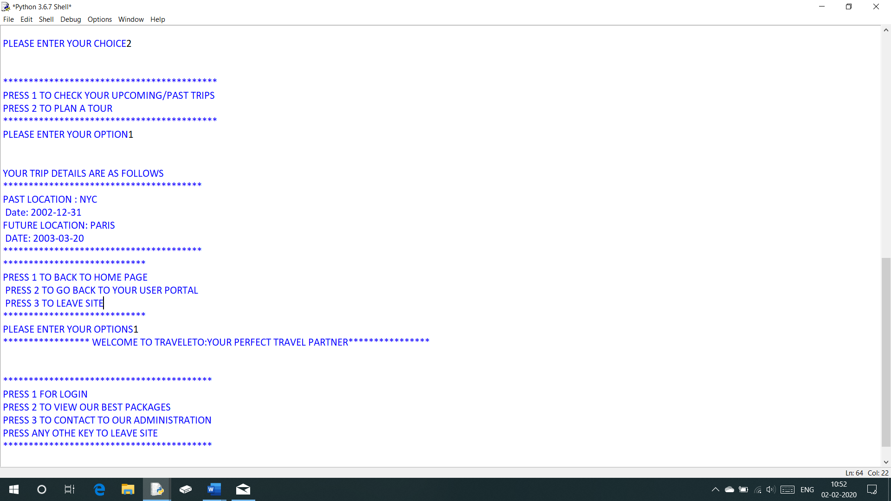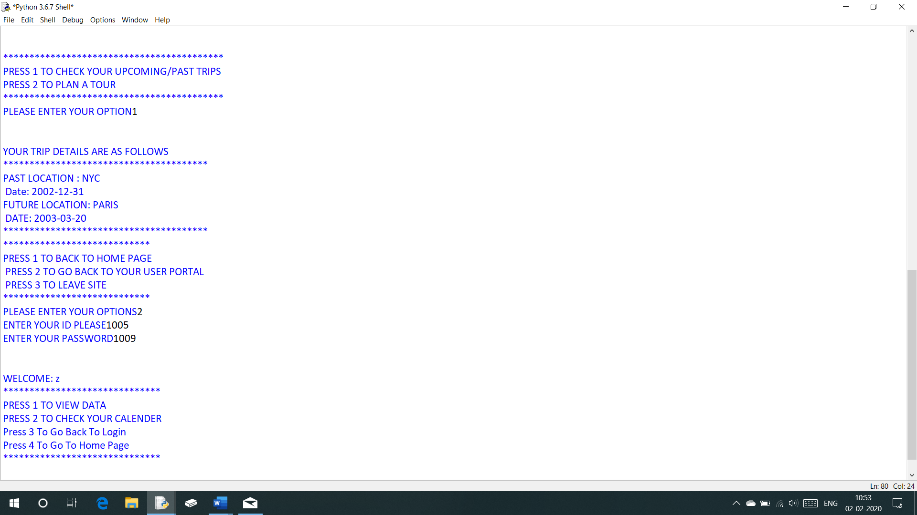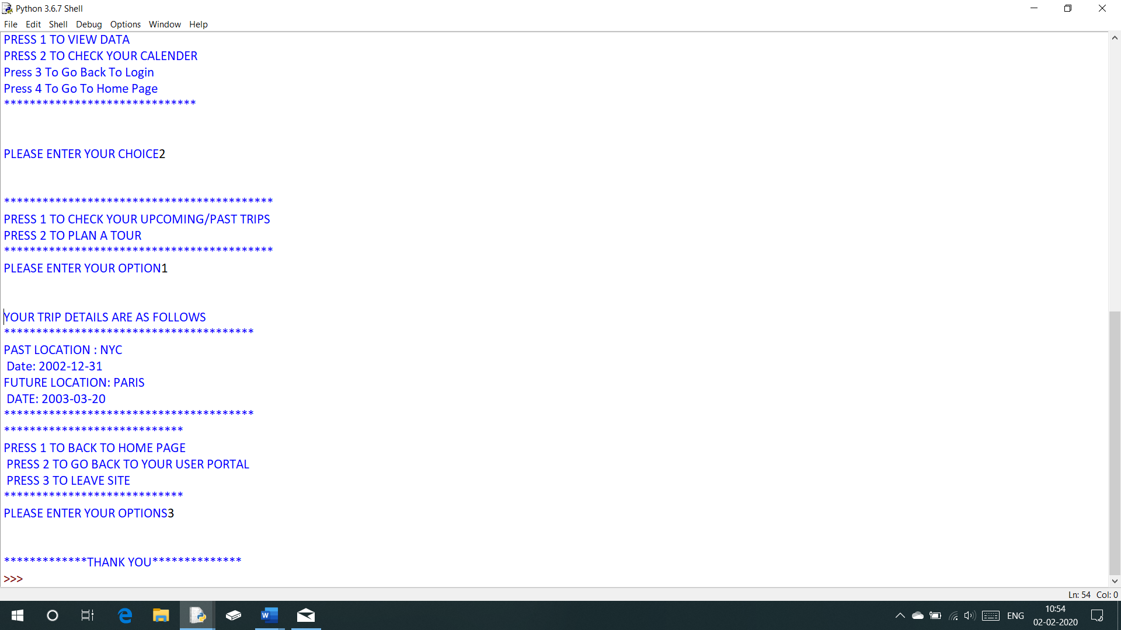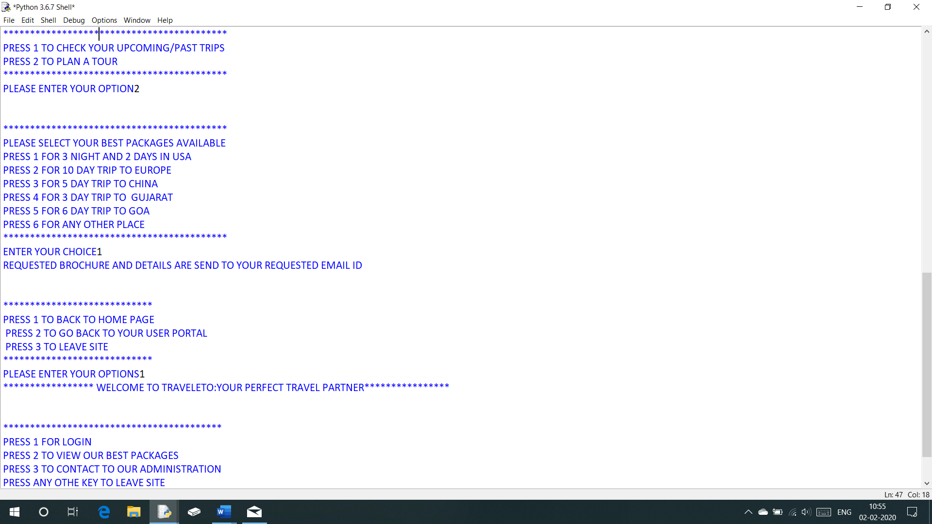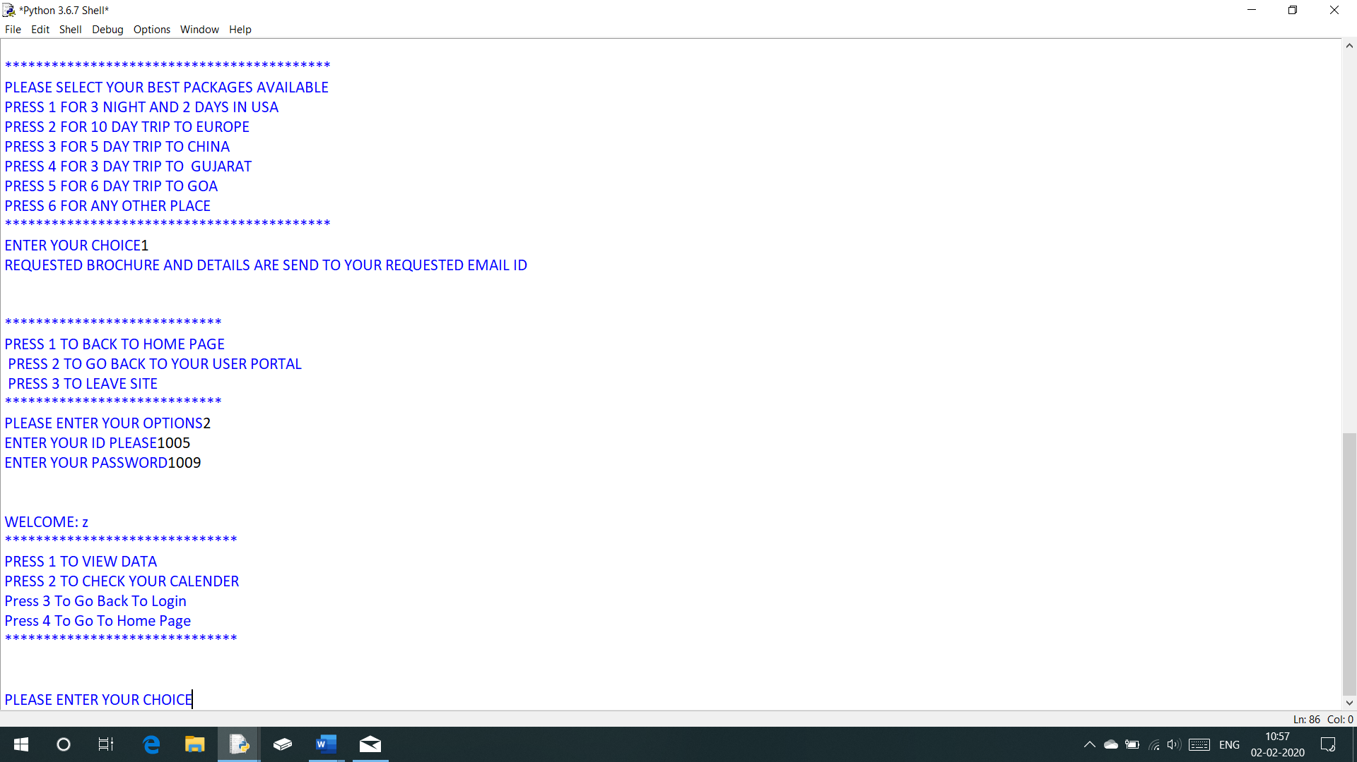

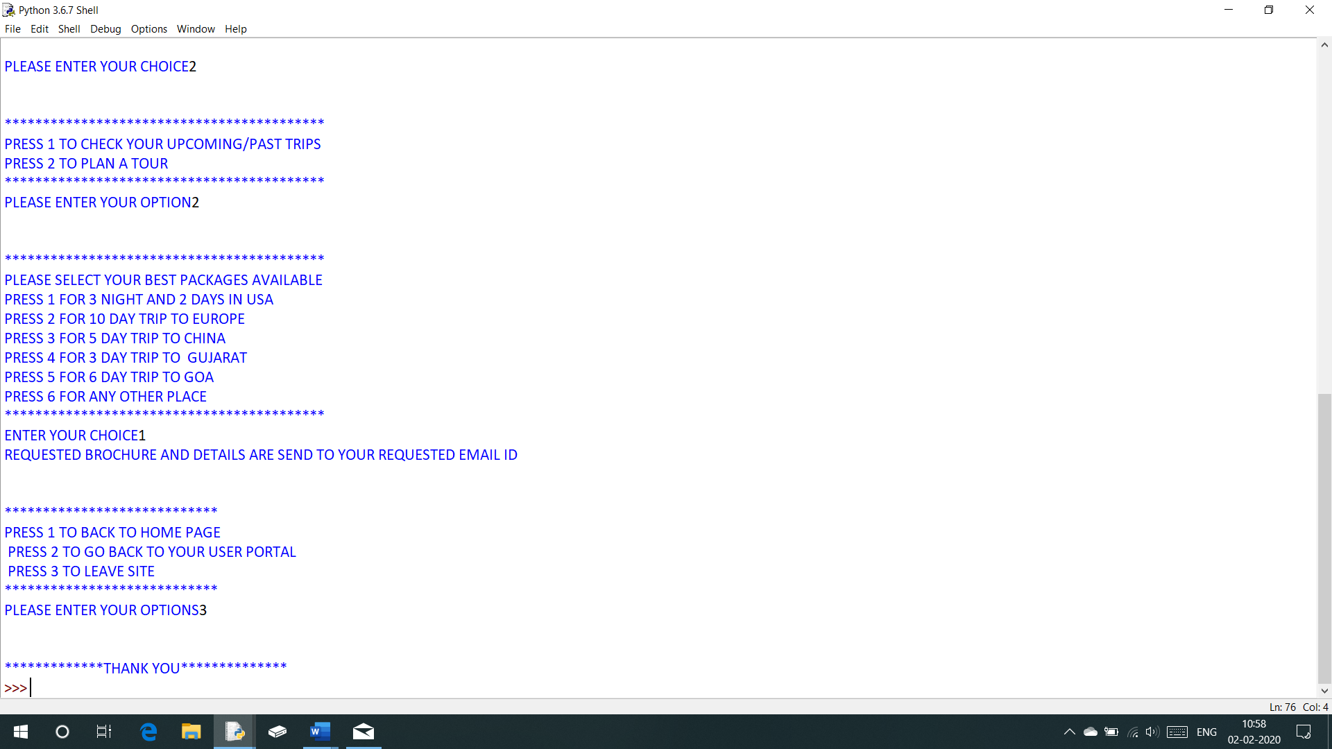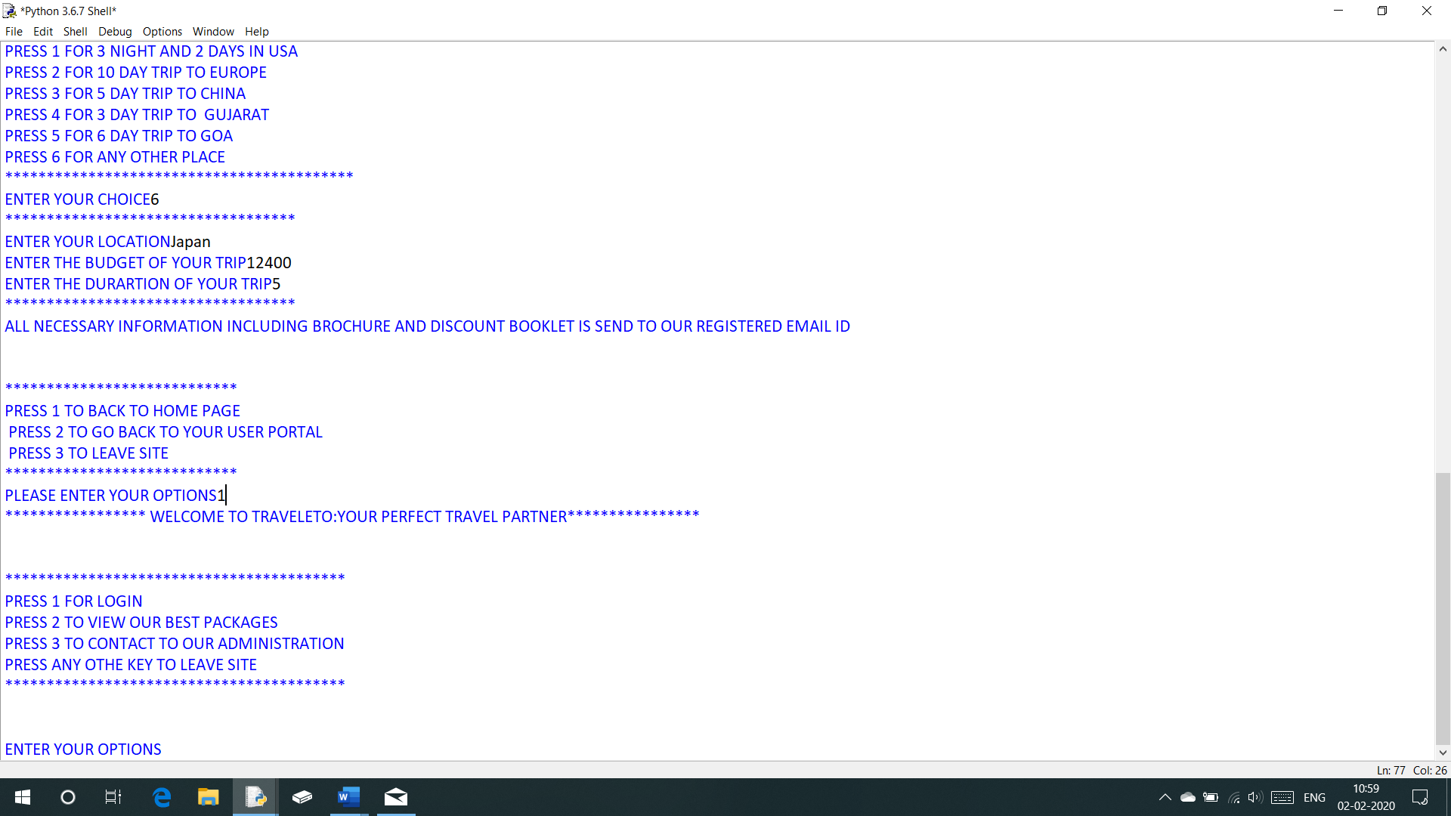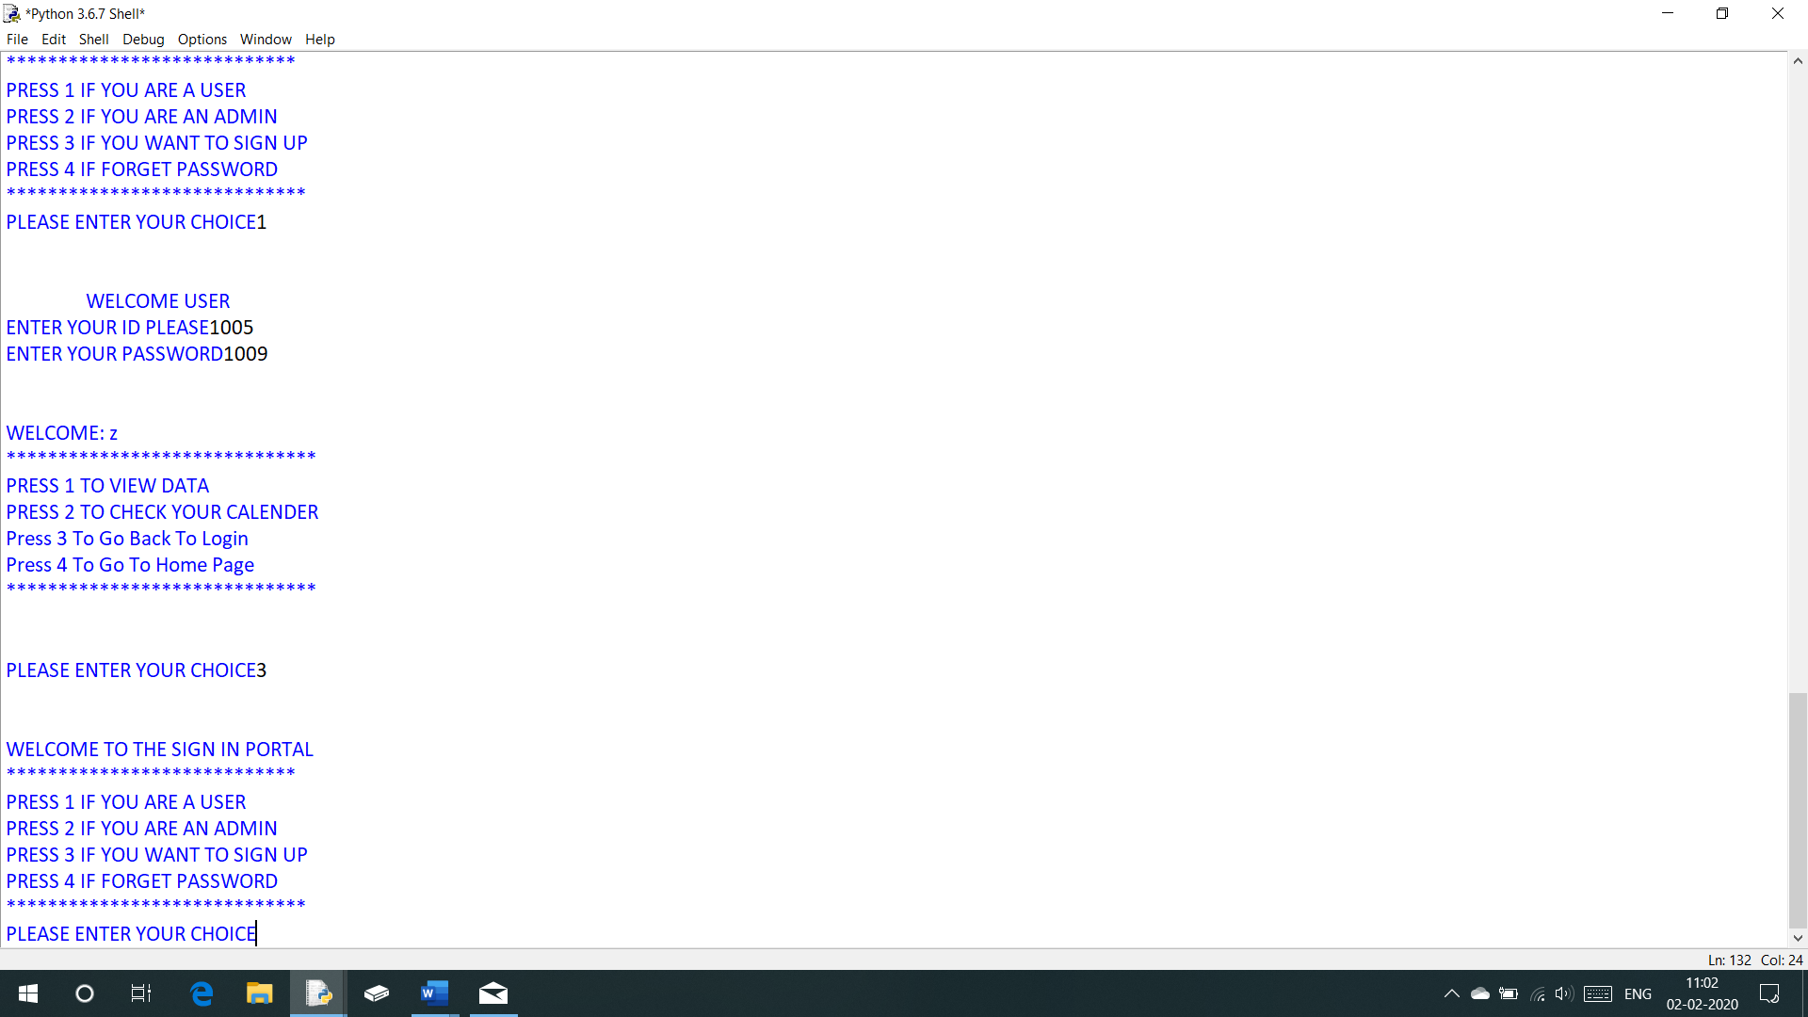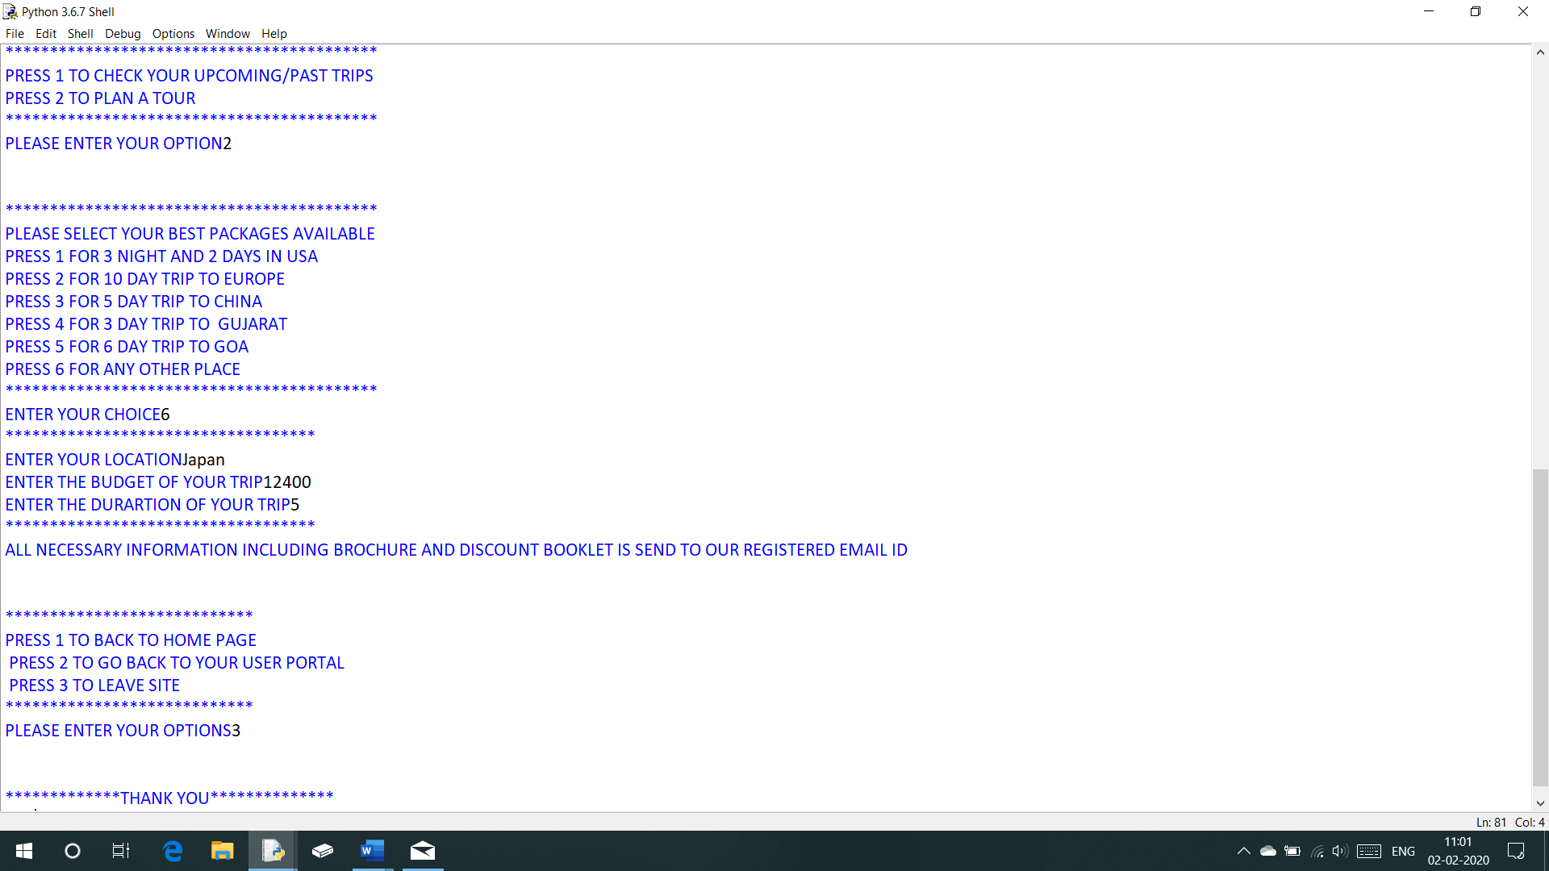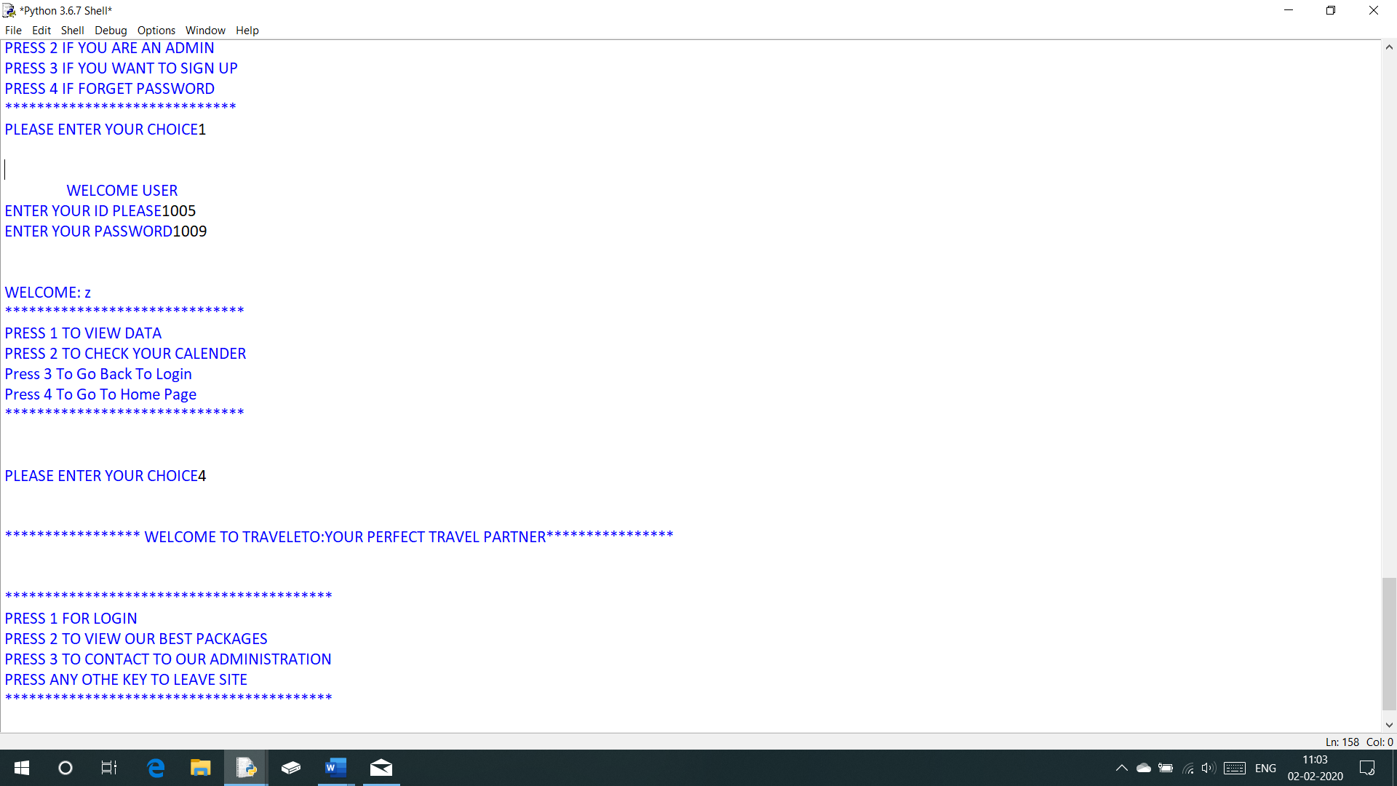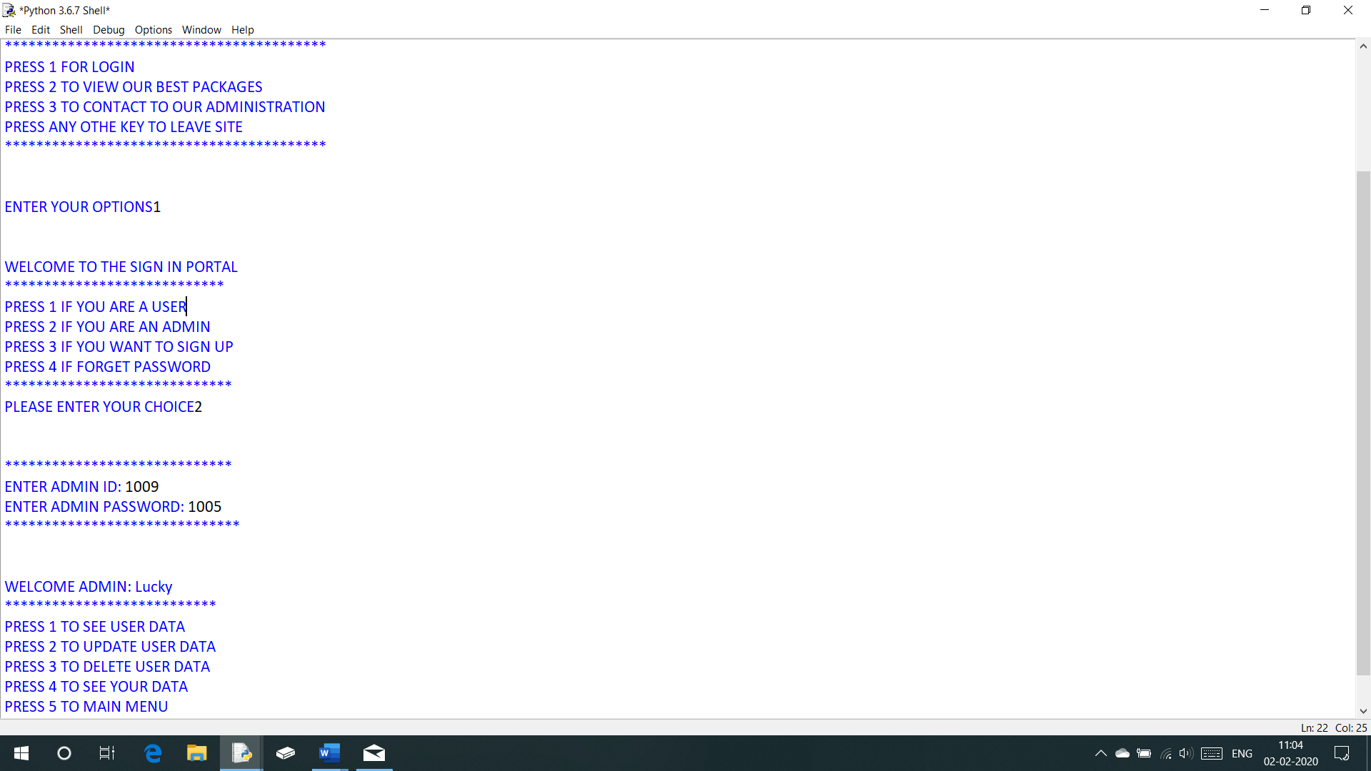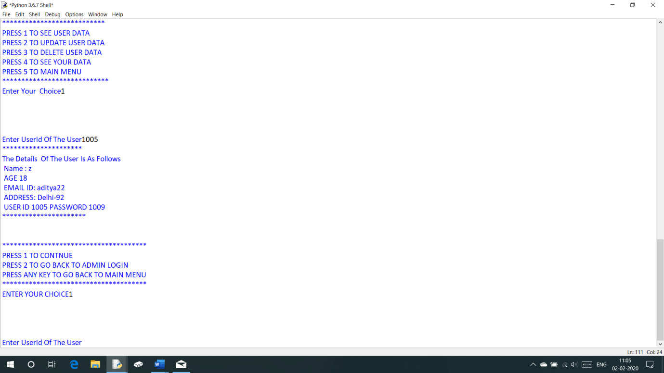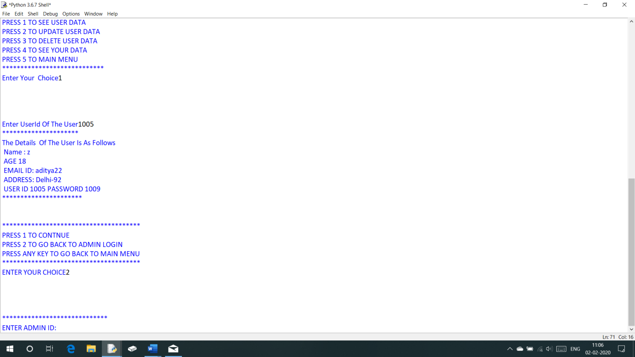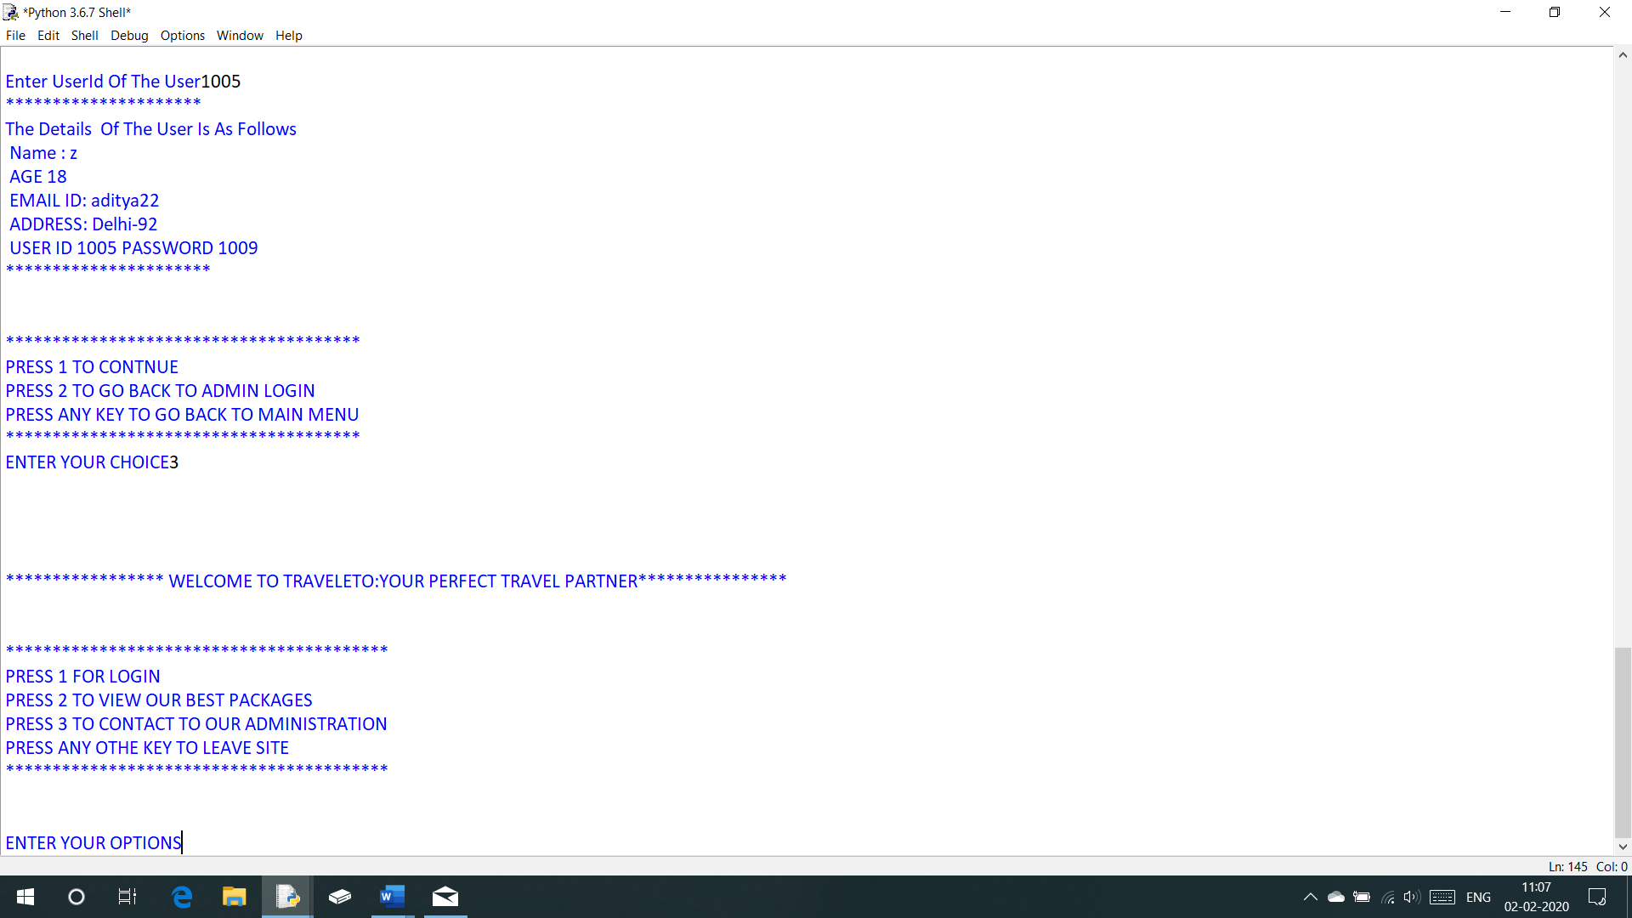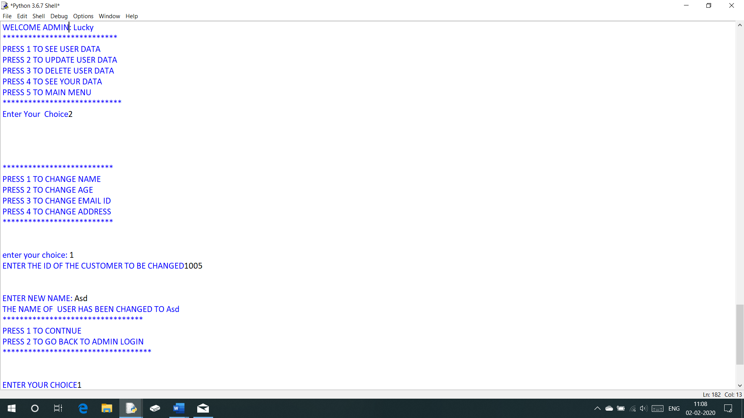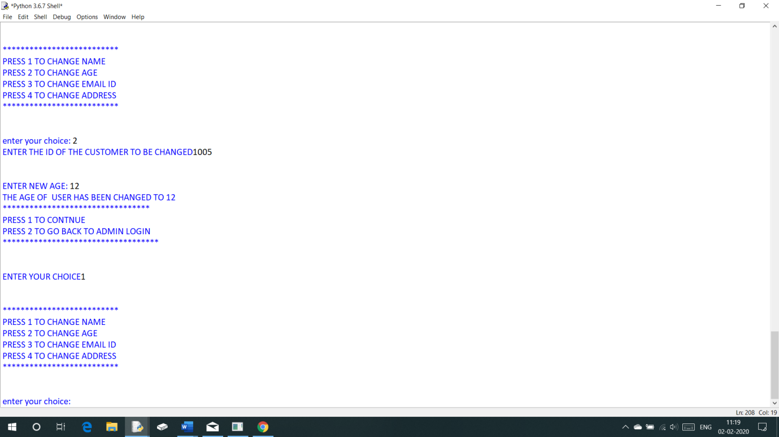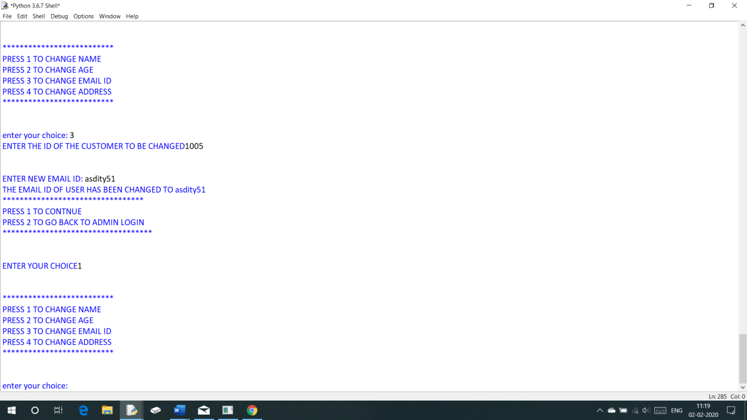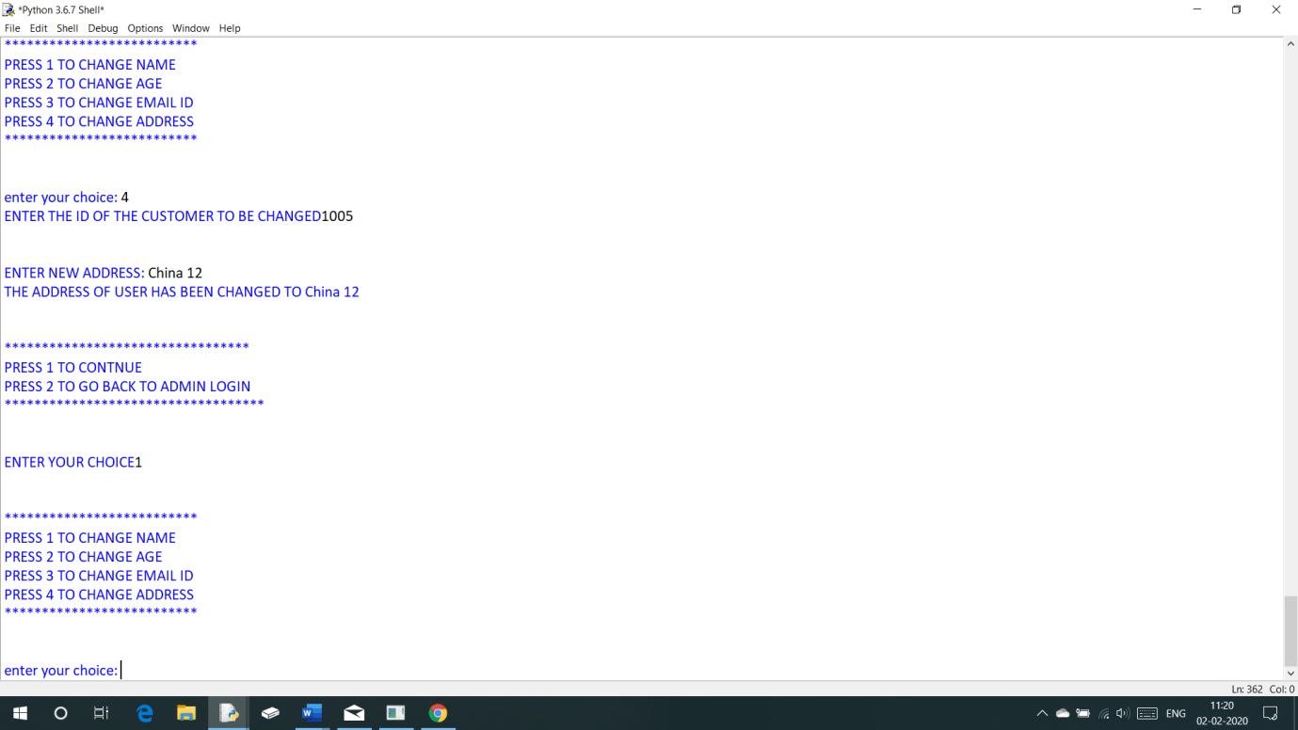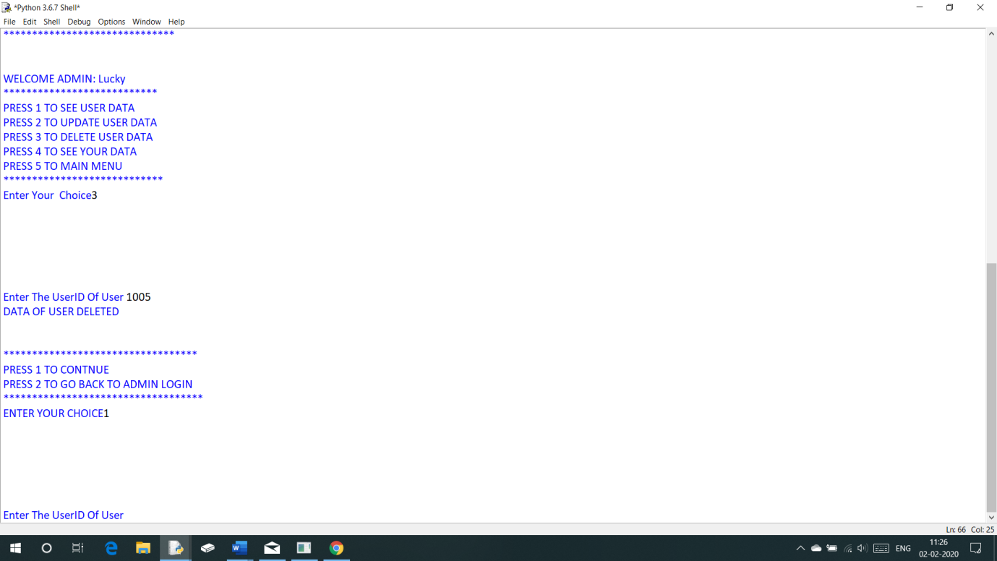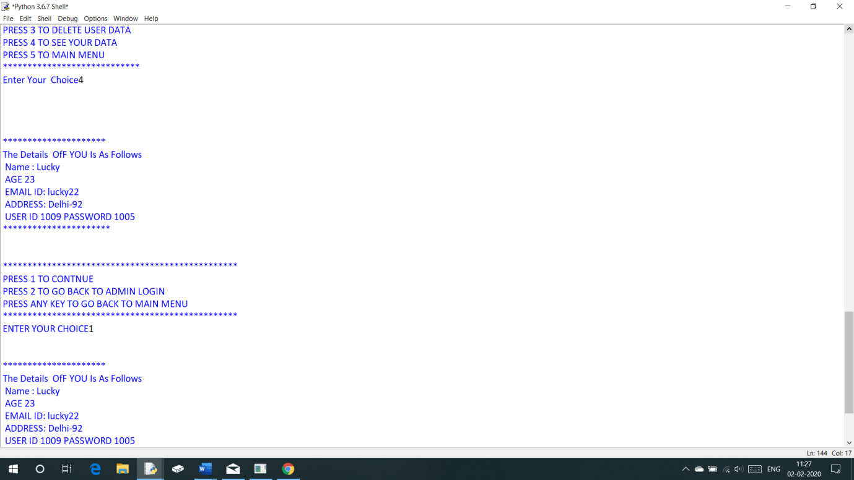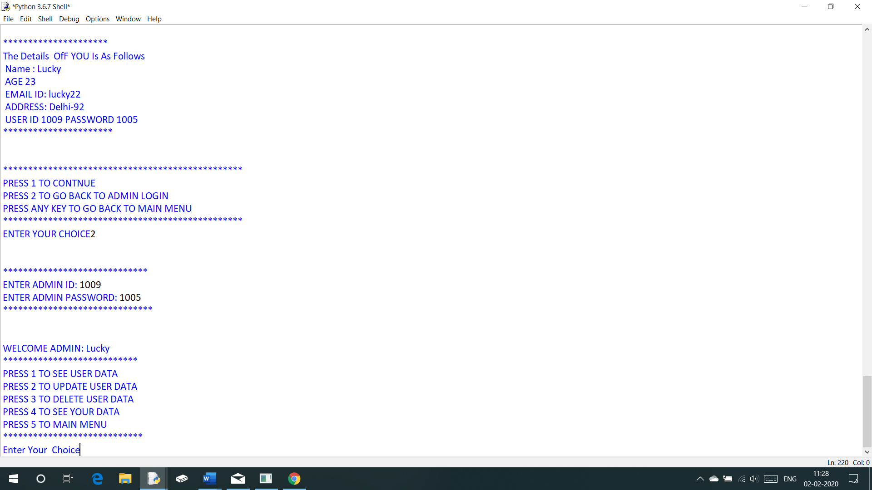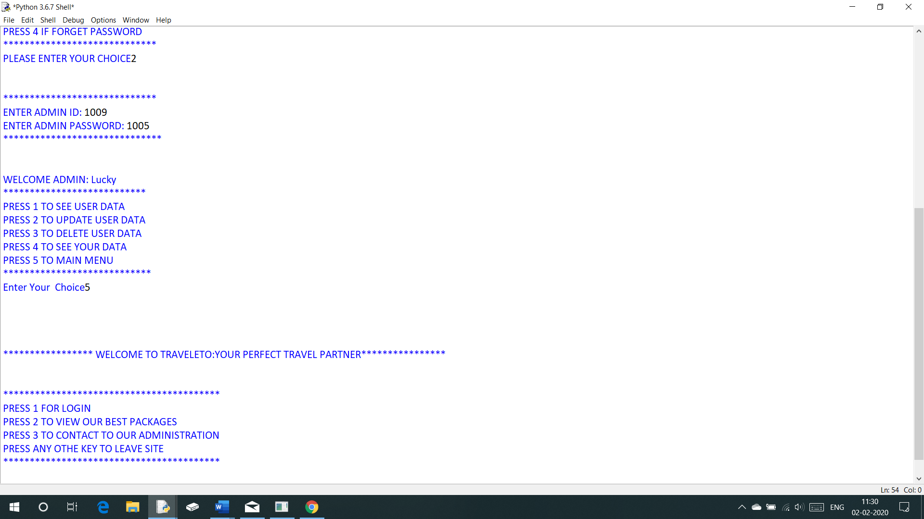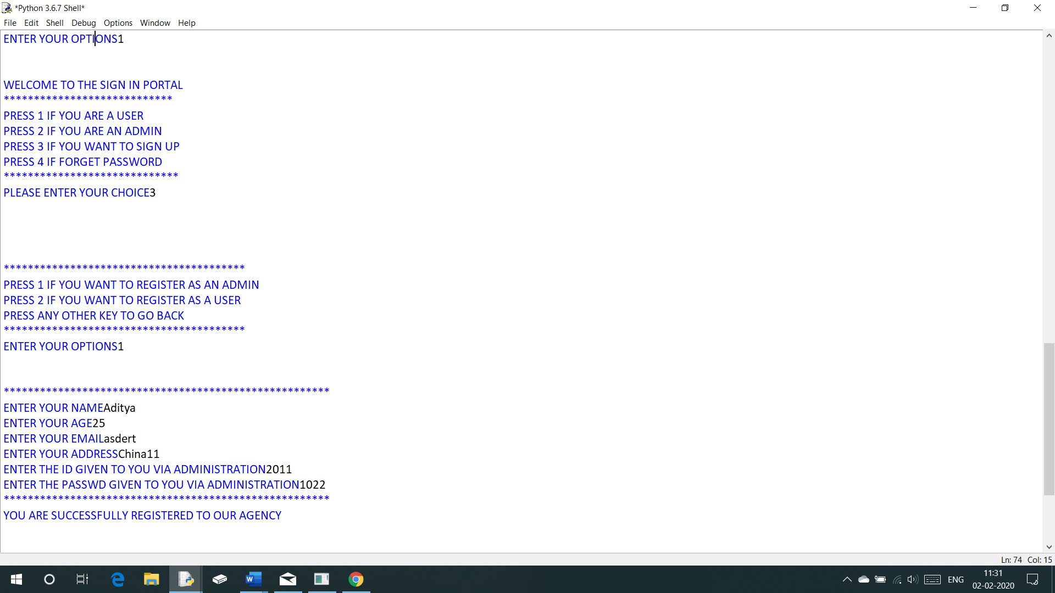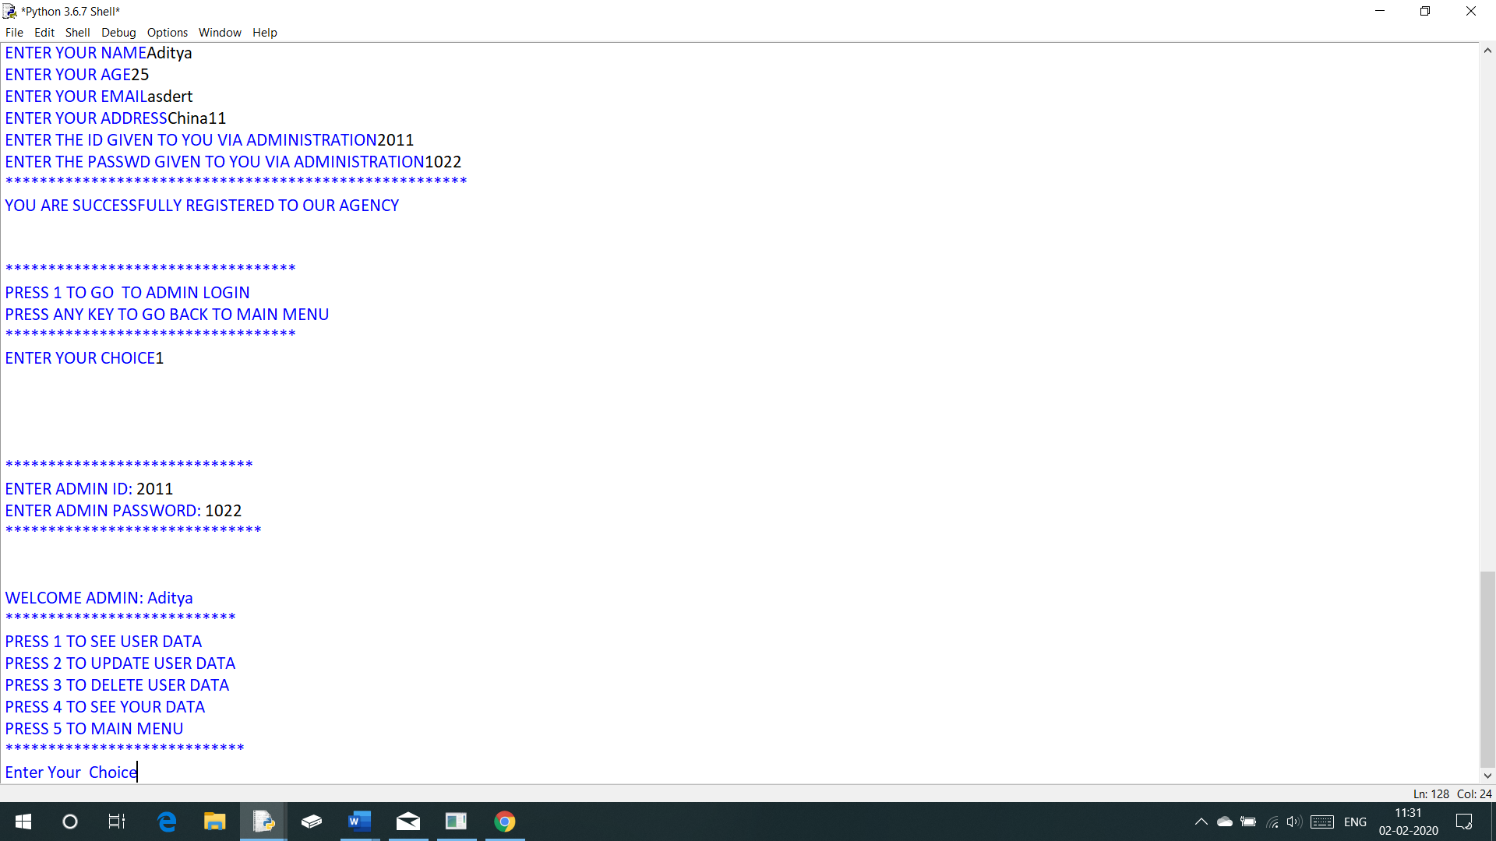

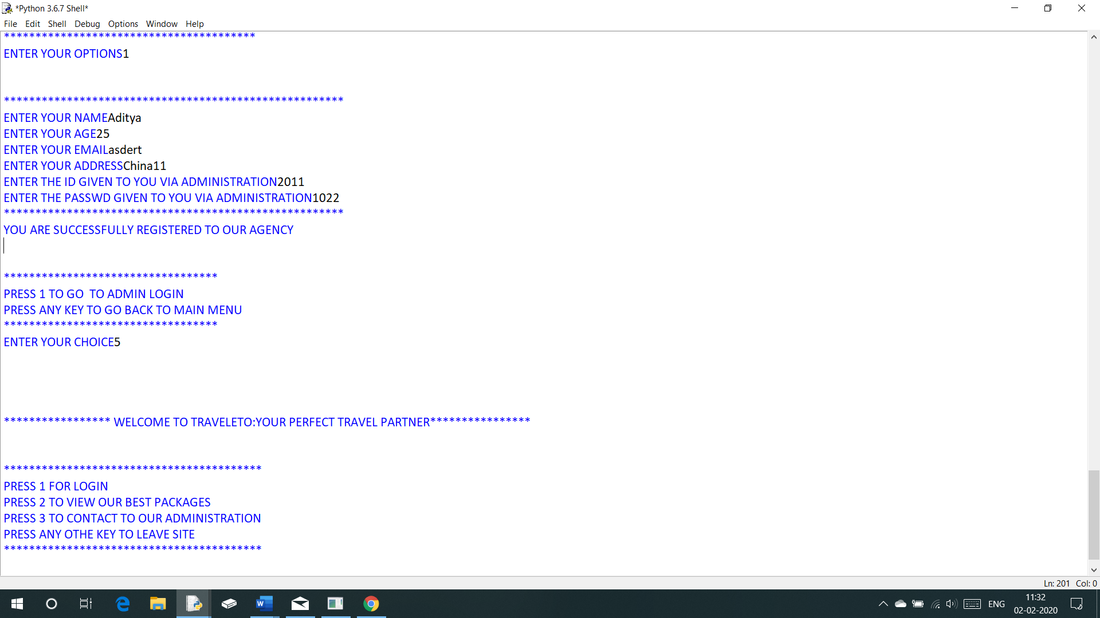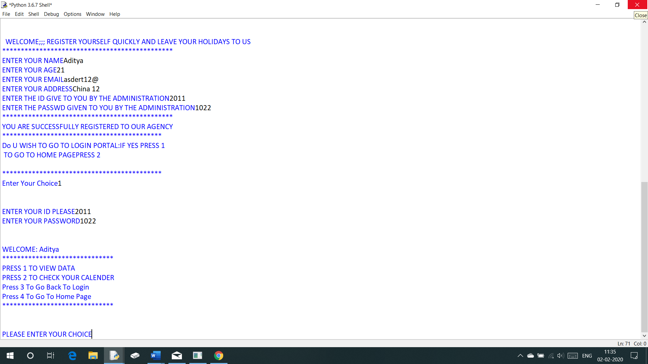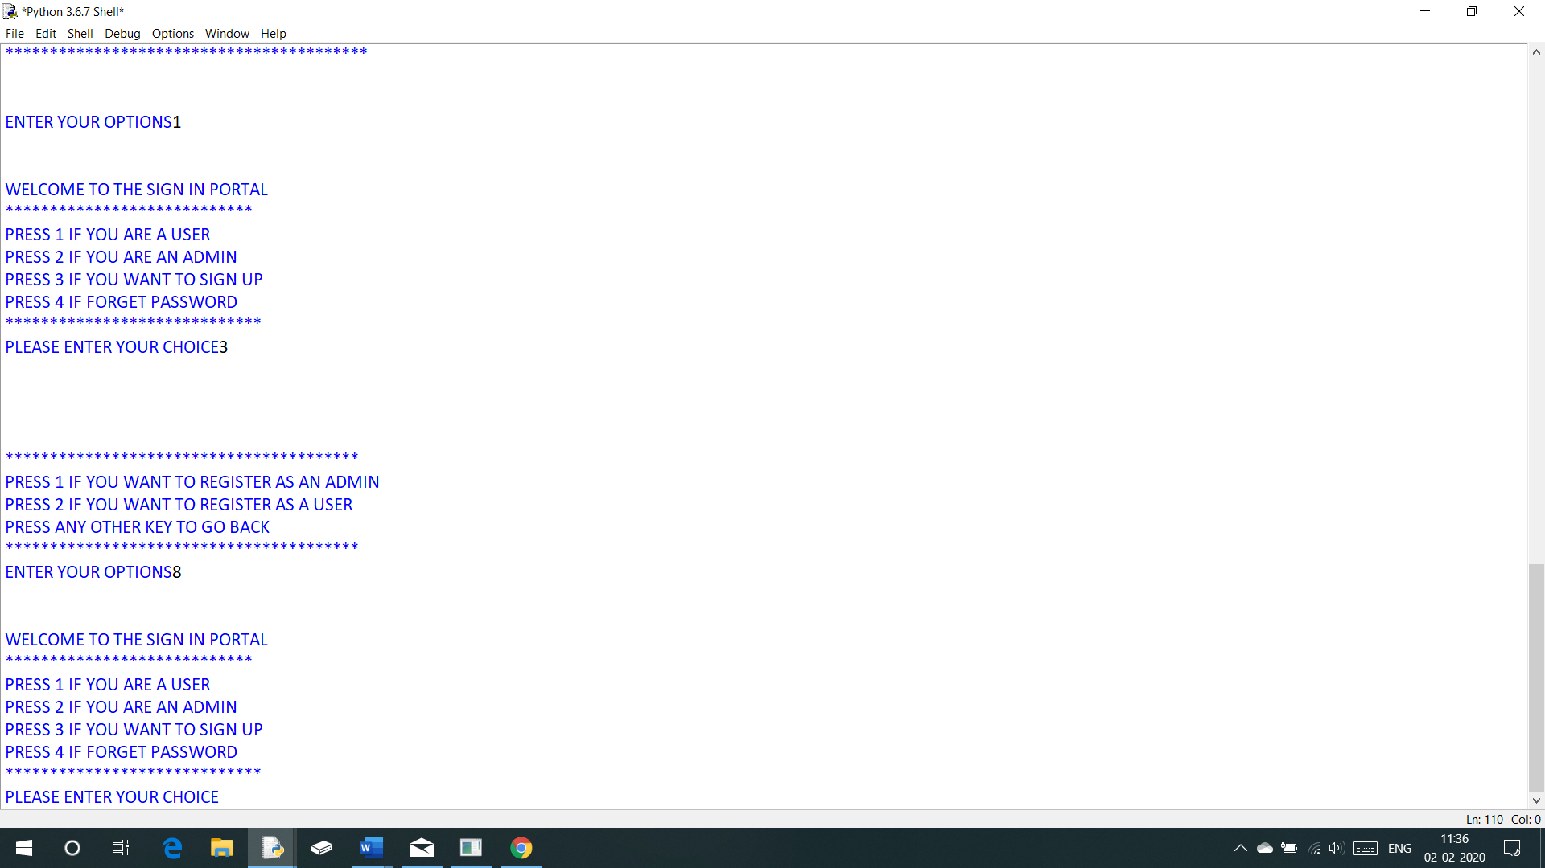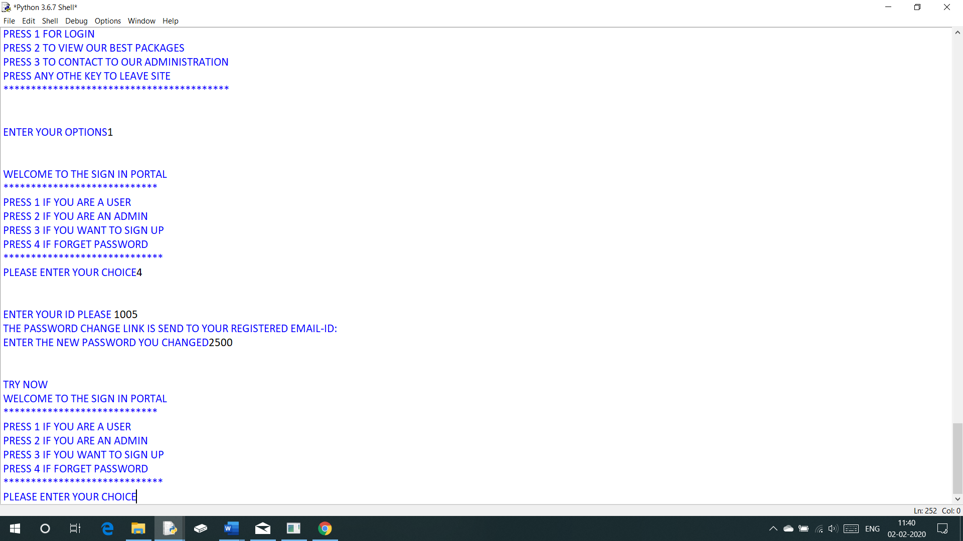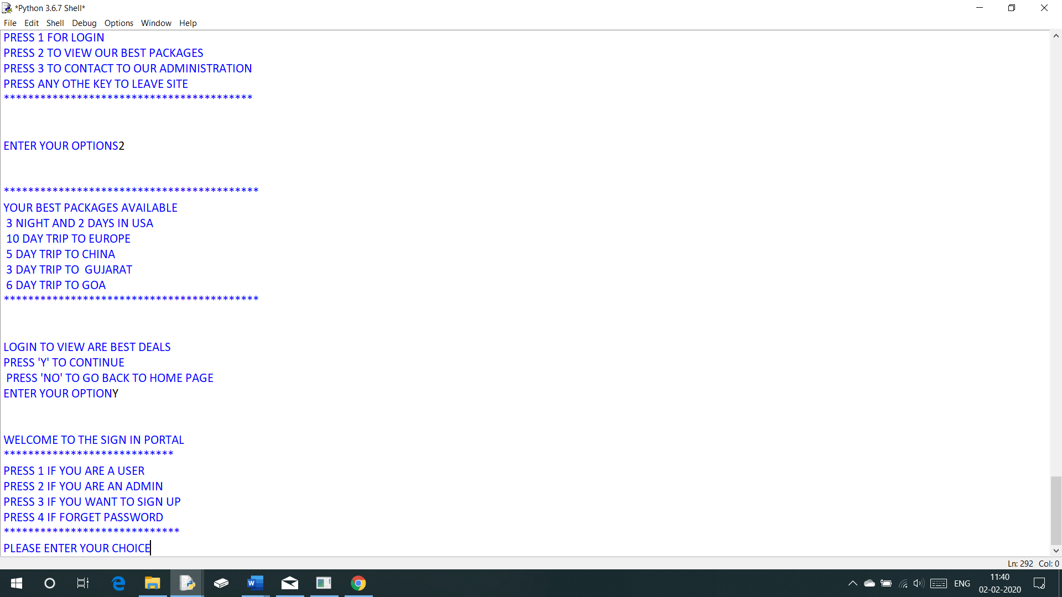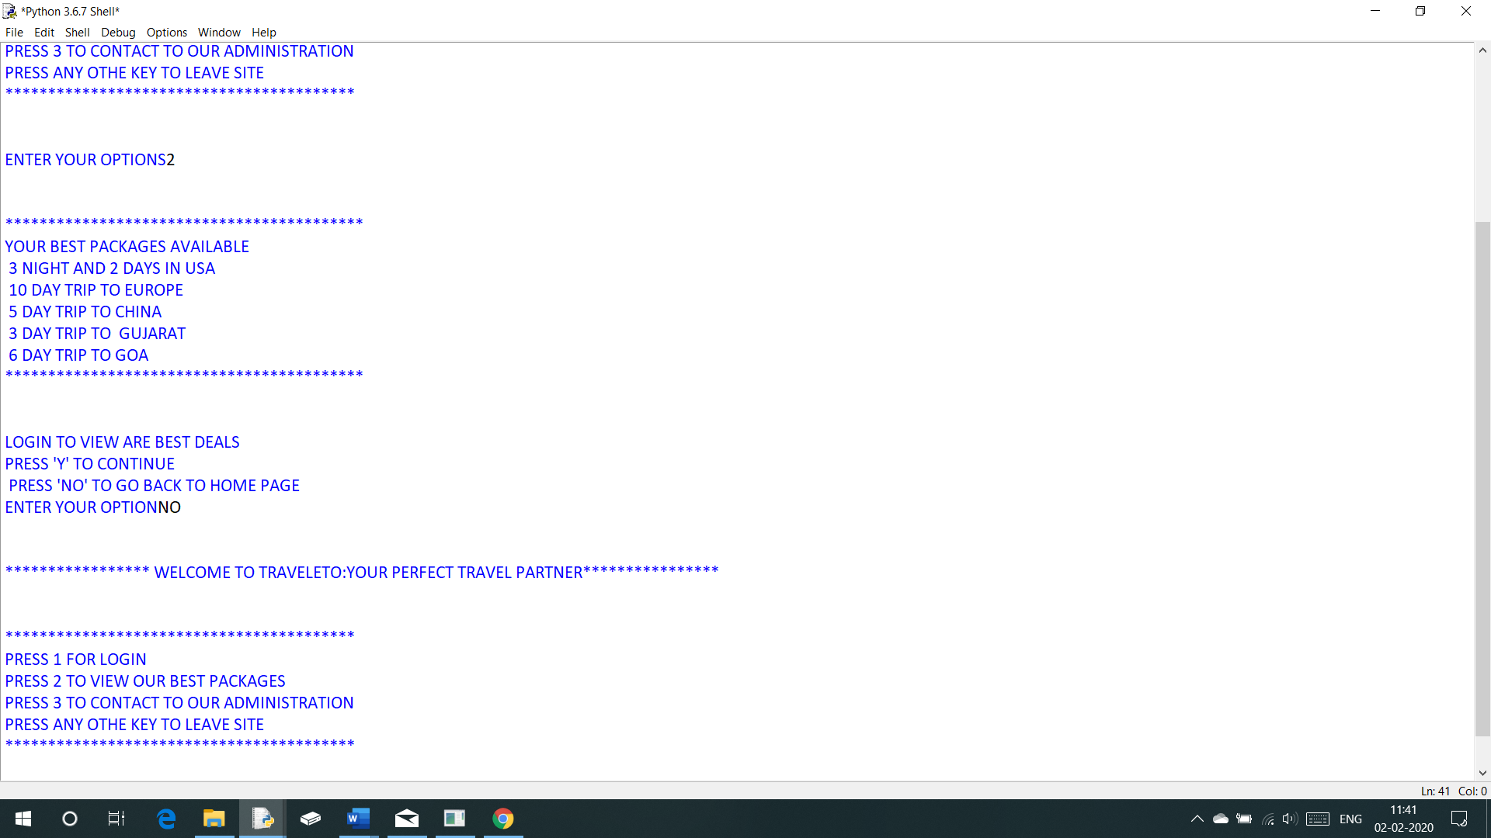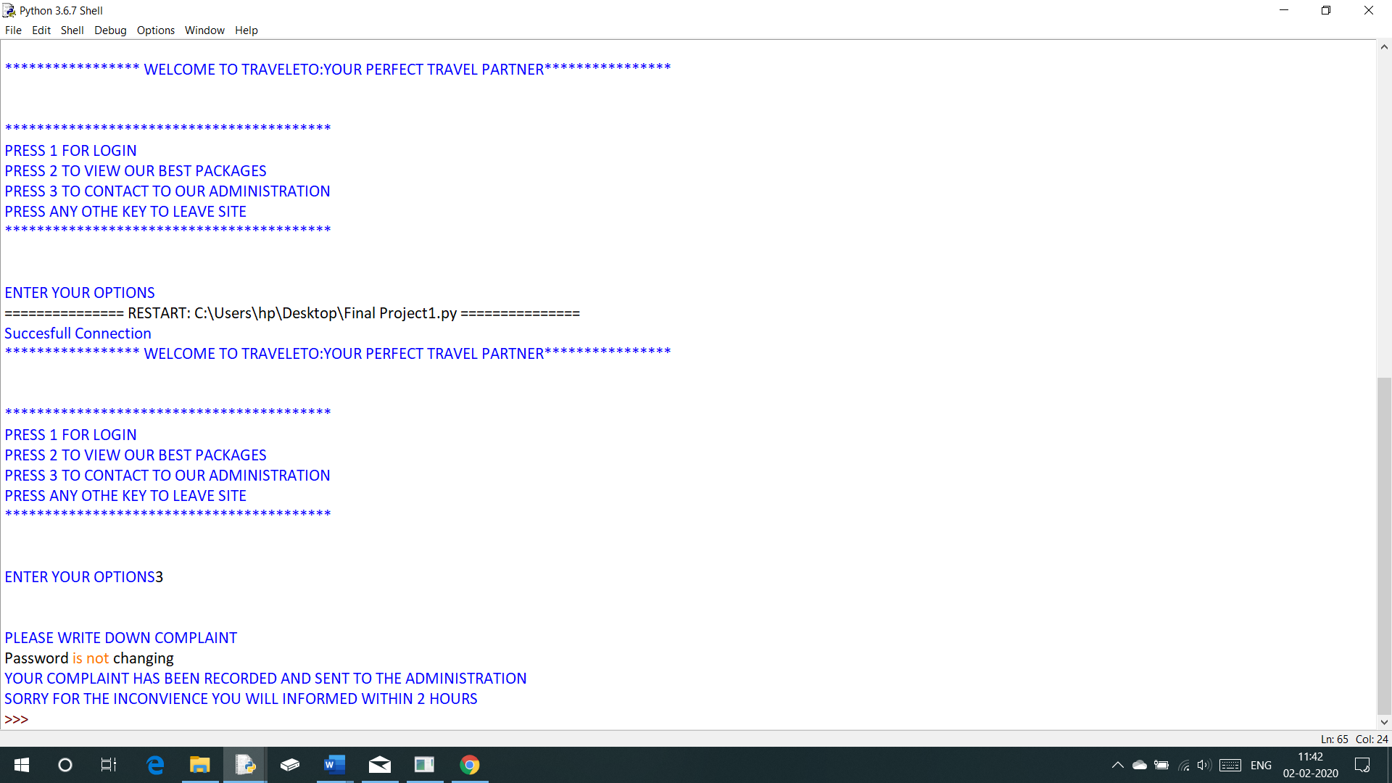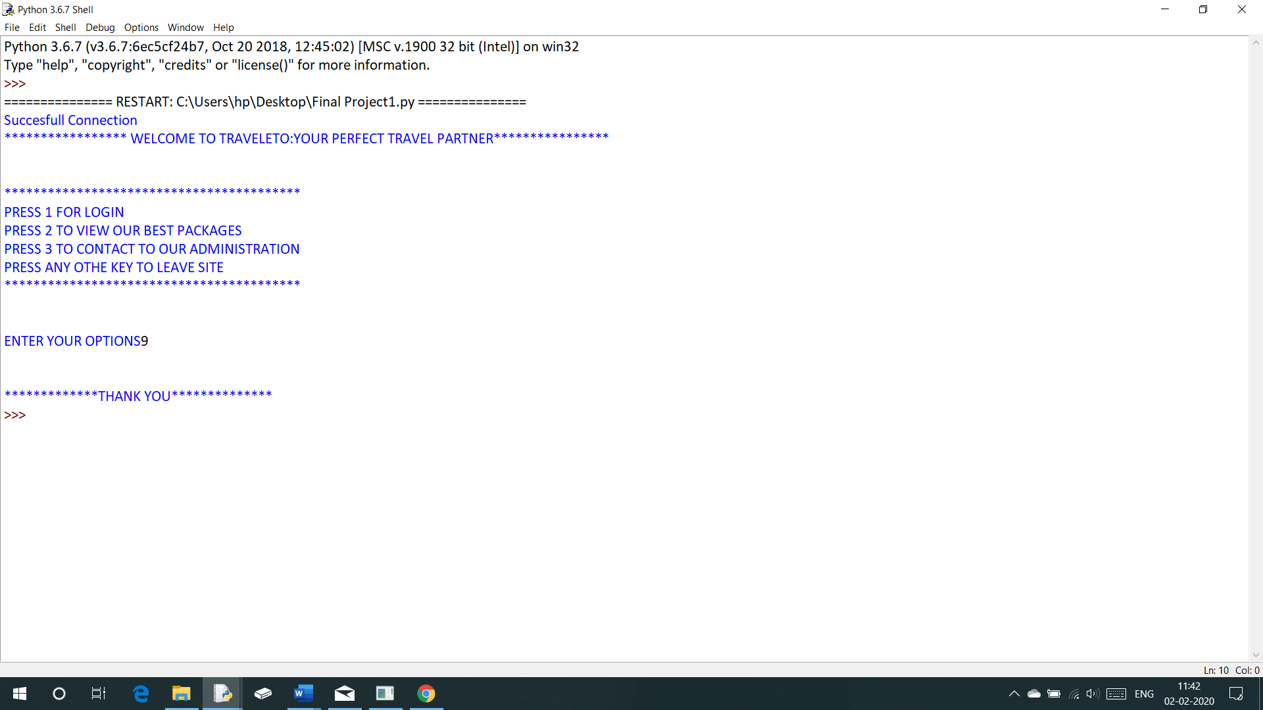

Bibliography

1. Sumita Arora, Computer Science with Python, Textbook for Class XII , Dhanpat Rai and Co., 12th Ediiton, 2019.
2. <https://www.w3schools.com/sql/>
3. <https://www.w3schools.com/python/>
4. Jagdish Prasad, Lecturer Computer Science , Ahlcon Public School, Lecture Notes.